A

PROJECT REPORT

ON

“CLASSIFICATION OF AGRICULTURAL PERISHABLE FOOD ITEMS”

Submitted in partial fulfillment of the requirements

for the degree of

BACHELOR OF TECHNOLOGY

in

Electronics & Communication Engineering

Submitted by

1. (SHUBHAM PANDEY) (1613331206)
2. (VINAYAK JHA) (1613331231)
3. (PRASHANT VAISH) (1613331143)

Under the Supervision of

Dr. Laxman Singh (Associate Professor, ECE)

Noida Institute of Engineering &Technology, Greater Noida (UP), India

 

Dr. A.P.J. Abdul Kalam Technical University, Lucknow (UP), India

AUGUST – 2020

**DECLARATION**

We hereby declare that this submission is our own work and that, to the best of my knowledge and belief, it contains no material previously published or written by another person nor material which to a substantial extent has been accepted for the award of any other degree of the university or other institute of higher learning, except where due acknowledgement has been in the text.

Signature: shubham pandey

Name: Shubham Pandey

Roll No.: 1613331206

Date: 1st Aug,’20

Signature: vinayak jha

Name: Vinayak Jha

Roll No.: 1613331231

Date: 1st Aug,’20

Signature: prashant vaish

Name: Prashant Vaish

Roll No.: 1613331143

Date: 1st Aug,’20

**CERTIFICATE**

This is to certify that the project entitled **“**CLASSIFICATION OF AGRICULTURAL PERISHABLE FOOD ITEMS**”** submitted by Shubham Pandey (1613331206), Vinayak Jha (1613331231) and Prashant Vaish (1613331143) in the partial fulfillment of the requirements for award of Bachelor of Technology in Electronics and Communication Engineering from Dr. A.P.J. Abdul Kalam Technical University, U.P., Lucknow under my supervision. The project embodies result of original work and studies carried out by the student’s their self and the contents of the project do not form the basis for the award of any other degree to the candidate or to anybody else from this or any other University/Institution.

**Dr. Laxman Singh**

Associate Professor (ECE)

NIET, Greater Noida

**ABSTRACT**

In writing the abstract, one should avoid the following things.

1. Any technical term that most readers do not understand should be avoided.
2. Any abbreviation or acronym that is not commonly used should be avoided.
3. Abstracts should not contain a bibliography or citations.
4. Abstracts should not contain any tables or graphs.
5. Abstracts must give only minimal reference to any earlier work.
6. Abstract should only include procedures done by the group.
7. One should not put acknowledgements in the abstract.

Abstract helps people quickly to determine if they want to read the entire report. Consequently, at least ten times as many people will read an abstract as any other part of the total work. It's like an advertisement of the work done. If one wants judges and the public to be excited about the project, then he must write an exciting, engaging abstract.

Since an abstract is so short, each section is usually only one or two sentences long. Consequently, every word is important to conveying the message. If a word is boring or vague, one should refer to a thesaurus and find a better one. If a word is not adding something important, one should not use it. But, even with the abstract's brief length, one should not be afraid to reinforce a key point by stating it in more than one way or referring to it in more than one section.

# ACKNOWLEDGEMENT

In the absence of mother the birth of a child is not possible and in the absence of teacher the right path of knowledge is impossible. This project is by far the most significant accomplishment in our life and it would be impossible without people who supported us and believed us.

We would like to extend my gratitude and my sincere thanks to my honorable, esteemed guide **Dr. Laxman Singh** (Assistant Professor (ECE)), Department of Electronics and Communication Engineering, NIET, Greater Noida for their immeasurable guidance and valuable time that he devoted for project. We sincerely thank for their exemplary guidance and encouragement. His trust and support inspired me in the most important moments of making right decisions and we are glad to work with him.

We would also like to give very special thanks to our HOD Sir Dr. V.K.Pandey (Professor). Also we would also like to give thanks to our project coordinator and my teacher’s for their support, help and encouragement during this work.

We would like to thank all my friends for all the thoughtful and mind stimulating discussions we had, which prompted us to think beyond the obvious.

We have enjoyed their companionship so much during my stay at NIET, Greater Noida. We would like to thank all those who made my stay in NIET, Greater Noida an unforgettable and rewarding experience.

A boat held to its moorings will see the floods pass by; but detached of its moorings, may not survive the flood. The support of all the members of our family (specially our parents, our elder sisters and our loving younger brother) motivated us to work even while facing the Blues. We dedicate this work to them.

Name- Shubham Pandey (1613331206)

Name- Vinayak Jha (1613331231)

Name- Prashant Vaish (1613331143)

**TABLE OF CONTENTS**

**Title**  **Page No.**

Declaration ii

Certificate iii

Abstract iv

Acknowledgement v

Table of contents vi

List of tables vii

List of figures viii

**CHAPTER 1: INTRODUTION 1-4**

1.1 Motivation 2

1.2 Objective 3

1.3 Key Challenges 4

**CHAPTER 2: THEORY OF PROJECT 5-11**

2.1 Classification 5

2.1.1 What is Classification 5

2.1.2 Types of Classification 5

2.2 Image Recognition 6-8

2.2.1 Image Processing Stages 6

2.2.2 How AI helps 7

2.2.3 How does it work 7

2.2.4 Techniques for Image Processing 8

2.3 Software used in project 9-11

2.3.1 Spyder IDE 9

2.3.2 TensorFlow 10

2.3.3 Keras 10

2.3.4 MatplotLib 10

2.3.5 Cuda 11

2.4 Hardware used in project 11

**CHAPTER 3: ARCHITECTURE OF PROJECT 12-23**

3.1 Dataset 12-15

3.2 Algorithm 16-18

3.3 Result and Discussion 18-23

**CHAPTER 4: CONCLUSION 24**

**CHAPTER 5: REFERENCE/COMPARISON 25-26**

**LIST OF GRAPHS**

**Graph No.:** **Graph Name:**  **Page No.**

Graph3.3.A Accuracy vs. Epoch 18

Graph3.3.B ROC curve for 1st Class 21

Graph3.3.C ROC curve for 2nd Class 21

Graph3.3.D ROC curve for 3rd Class 22

**LIST OF FIGURES**

**Figure No.** **Figure Name** **Page No.**

Figure3.2.1 Keras Conv2D parameter 17

Figure3.2.2 code for Conv2D 17

Figure3.3.1 Accuracy of model 19

Figure3.3.2 Model Summary 19

Figure3.3.3 Classification Report 20

Figure3.3.4 Confusion Matrix 20

**Chapter 1: INTRODUCTION**

Some genuine applications, for example, face acknowledgment, self-sufficient vehicles, object acknowledgment and robotics rely on endeavoring to imitate the capacities of the human mind so as to get pictures. In the food industry, products of the soil are a significant piece of new production and their classiﬁcation is an augmentation of object acknowledgment. Customarily foods grown from the ground are reviewed outwardly via prepared faculty for quality assessment as a produce or a harvest. In any case, manual classiﬁcation presents numerous human-related imperatives for example, an individual waiting be familiar with the numerous attributes of leafy foods. Manual classiﬁcation requires a ceaseless and predictable viewpoint acknowledgment method to look after consistency. The agriculture industry presently applies motorized strategies for classiﬁcation and regularly depends upon computer vision for pre- and post-gathering examination of harvests. With the energetic improvement of our human culture, extra consideration has been paid to an amazing predominance, especially the food we eat. In the course of the most recent couple of years, computer vision have been broadly utilized in organic product acknowledgment techniques. Computer vision is a field of numerical examination of visual information as far as pictures of assorted types and this can be a provoking errand when applied to the food business. Visual information of products of the soil grows from paired to hyper unearthly pictures. Advances in imaging strategies have brought about increasingly refined computer vision prompting its utilization as a developing norm for some agricultural applications.

(1)

1.1 Motivation

In the agriculture industry, one of the most important requirements of computer vision is as a non-destructive technique for quality assessment, sorting, automated grading and robotic harvesting unlike many other techniques. Classification of fruit and vegetable is a relatively more complex problem due to the huge variety, for example, irregular intra-class shape, color and texture, and similar interclass shape, color and texture. These constraints have caused a lack of multi-class automated fruit and vegetable classification systems. An automated fruit and vegetable classification system with more complex information of fruit and vegetable may prove to be helpful for picking the right fruit and vegetable with the right nutrition. It may also help children and visually impaired people, and improve supermarket grocery self-checkouts. A summary of recent fruit and vegetable classification performed in different real-life applications is presented in *Table 1*. Recent state-of-the-art for fruit and vegetable classification and recognition are a combination of feature description and machine learning algorithms on visual data. Significant research has been reported for representation of different characteristics of fruit and vegetable as feature vectors. Despite much research, many challenges need to be overcome to build an effective fruit and vegetable classification system. Thus, this paper provides a comparative survey of associated limitation for classification of fruit and vegetable and the state-of-the-art computer vision techniques used for this task.

|  |  |
| --- | --- |
| Industry | Application |
| Food Industry | Quality Assessment |
| Agriculture | Robotic Harvesting |
| Retail | Supermarkets, Inventory |

**Table 1**

(2)

* 1. Objective

Significant evidence of efforts made toward the realization of an automated fruit and vegetable classification system are available, but no examples of commercial applications of such systems are available to date. Approximately, all previous efforts have a core idea of using one or more kind of the sensor along with a machine learning technique for identification of the features associated with the produce items for example, shape, color, texture and size to perform the classification. Identification of fruit and vegetable has a large number of challenges associated with it due to irregular shape, size and variable color. Much research has been performed to identify methods to address these challenges. Practically all physical aspects of fruit and vegetable have been considered as feasible features for effective classification. Initial efforts were made by using global features i.e. shape and color for classification and local features like texture were analyzed in more advanced approaches. Accurate and efficient vegetable recognition is of great importance in the field of robotic harvesting and yield mapping. An ideal vegetable recognition system is accurate that can be trained on an easily available dataset, shows real-time predictions and acclimates various types of vegetable. Therefore, in our research, we implement a fruit recognition classifier using CNN (Convolutional Neural Network). For the networks best performance, we used various combinations of hidden layers for five cases and observe the accuracies. The final experiment result shows the much-improved vegetable recognition rate. The mathematical model of the network is executed in python with tensorflow.

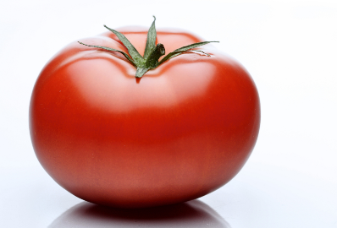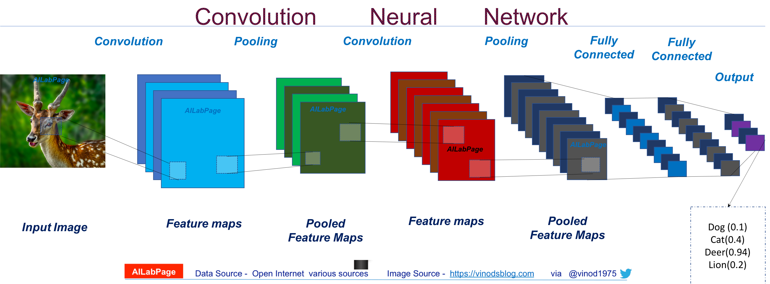

**Tomato**

(3)

1.3 Key Challenges

Recognition and classification of fruit and vegetable as a subset of object classification is an inherently more complex task than other subsets of object classification. Fruit and vegetable present crucial sensory and feature characteristics which are also dependent upon the wide spread applications of it. The key challenges involved in fruit and vegetable classification are categorized as:

* Appropriate sensor

The selection of a sensor for data acquisition is a key challenge for classification. Sensors ranging from black and white (B/W) cameras to non-visual sensors such as acoustic and tactile sensors have been used for classification of fruit and vegetable, but not all sensors are equally suitable for all applications. As evident from both acoustic and tactile sensors are less suitable for non- destructive classification and recognition. These sensors either need physical contact or excitation of the fruit or vegetable for data acquisition.

* Feature selection and representation for classification

Features are the physical characteristics of an object that can distinguish it from other objects. Fruit and vegetable have many physical characteristics i.e. color, texture, shape and size, which can be used as features for effective classification. Fruit and vegetable have numerous inter and intra-class variations and similarities. The interclass variation are major changes i.e. changes in color, texture and shape whereas the intra-class variations are generally much more subtle and hard to differentiate i.e. different kinds of mangos or apples have only slight variations in features.

* Machine vision approach

Machine vision approaches are a set of machine learning algorithms used for classification and recognition of images. Extensive research has been performed since the early 1980s. The algorithms designed can be categorized in many ways, a usual categorization is neural network (NN) based and handcrafted. The selection of an appropriate algorithm in any machine learning application is always a critical task but it is even more crucial in the case of fruit and vegetable.

(4)

**Chapter 2: THEORY OF PROJECT**

2.1 CLASSIFICATION

2.1.1 What is Classification?

Researchers organize plants, creatures, microscopic organisms, and other life structures into natural scientific categorizations known as classes, phyla, requests, families, and so forth. Similarly, organizations are starting to see the advantage of collecting items, consumer profiles, and other market information into classifications. Utilizing specific calculations, these organizations join comparative characteristics for information focuses and create reasonable groupings. This computerized reasoning, nearby its capacity to develop itself through AI, assesses how likely two items have a place with a similar class. The act of characterization with AI is taking on an undeniably significant job in present day business.

2.1.2 Types of Classification

These are the basic overview of some strategies computers use to categorize data points in business:

**Using Bayes’ Theorem,**which predicts the probability that a product belongs to a class based on its features. If many parts of the product seem to share characteristics with the category, then it’s likely part of it.

**Decision Trees**. You’ve likely heard of this type if you’ve played the “20 questions” game. The algorithm slowly deduces the attributes of the product by asking questions to narrow down where the data point belongs.

**K-nearest Neighbors**. This algorithm compares a new piece of data with other similar data points already in the database. It has a population application predicting the prices of goods in the marketplace and providing product recommendations.

**Neural Networks**. It is popular in the machine learning field since it simulates how the human brain itself picks up new information. Arguably the most challenging type of AI to develop, neural networks have caught the interest of large enterprises like Facebook, Google for their versatility and virtually endless applications.

(5)

2.2 IMAGE RECOGNITION

Image processing means converting an image into a digital form and performing certain operations on it. As a result, it is possible to extract some information from such an image. Image recognition is one of the image processing stages. Those specific features which we mentioned include people, places, buildings, actions, logos and other possible variables in the images. Therefore, image recognition is a process of identifying and detecting an object in a digital image, and one of the uses of computer vision. Sometimes it is also called image classification, and it is applied in more and more industries. One of them is e-commerce.

2.2.1 Image Processing Stages

* Color image processing — the colors are processed
* Image enhancement — the quality of the image is improved and the hidden details are extracted
* Image restoration — the image is cleaned from blurs and other unpleasant things
* Representation and description — the processes data is visualized
* Image acquisition — the image is captured and converted
* Image compression and decompression — the size and resolution of the image are changed, if necessary
* Morphological processing — the structure of the image’s objects is described
* Image recognition — specific features of the image’s objects are identified

(6)

2.2.2 How AI helps

* Facial Recognition

With the help of AI, a facial recognition system maps facial features from an image and then compares this information with a database to find a match.

* Object Recognition

Object recognition systems pick out and identify objects from the uploaded images. Visual search is probably the most popular application of this technology.

* Pattern Recognition

Pattern recognition means finding and extracting specific patterns in a given image. Those can be textures, facial expressions, etc.

* Text Detection

Text detection is about detecting text and extracting it from an image.

2.2.3 How does it works?

The first step here is gathering and organizing the data. Computers perceive a picture as a vector or raster image. So after the constructs depicting objects and features of the image are created, the computer analyzes them. Then, the data is organized — the important information is extracted, and the unnecessary one is left out. The second step of the image recognition process is building a predictive model. The classification algorithm has to be trained carefully, otherwise, it won’t be able to deliver its function. When everything is done and tested, you can enjoy the image recognition feature.

(7)

2.2.4 Techniques for Image Processing

There are only two of them: analog and digital. The analog method is used for processing hard copies of images. The mission of the digital one is to manipulate digital images using computer algorithms.

Image restoration is considered both as a stage and technique of image processing. Here are some of the other techniques:

* Pixilation — turning printed pictures into the digitized ones
* Linear filtering — processing input signals and producing the output ones which are subject to the constraint of linearity
* Edge detection — finding meaningful edges of the image’s objects
* Anisotropic diffusion — reducing the image noise without removing crucial parts of the picture
* Principal components analysis — extracting the features of the image

(8)

2.3 SOFTWARE USED IN PROJECT

The one listed conflict in making a successful project can be the steps of unambiguous coding, which requires editing source codes, building executables and debugging in self. Alternatively, an IDE (Integrated Development Environment), enables programmer to blend in the different aspects of writing a computer program. It mainly has the editor and compiler tools to make it extremely useful for coders.

2.3.1 SPYDER IDE

The IDE we used is, SPYDER. It is an open source cross-platform IDE for scientific programming in Python language. It has number of useful packages in Python stack like, NumPy, SciPy, Matplotlib, pandas etc. This editor has an ability to explore and edit variables from GUI of computer. It also has a debugger linked to IPdb, for step by step execution. It comes with a built-in file explorer, for interacting with filesystems and managing projects. It is the most efficient IDE for the trouble-free implementation of Python code for the project of Artificial Intelligence using deep learning.

Deep Learning, is a subfield of machine learning as a set of algorithms that is inspired by the function of a human brain. The algorithm is mainly called as Artificial Neural Network (ANN). It is one of the growing field in technology which has got the best result in the study of robotics, image recognition, Artificial Intelligence (AI).

The most used library for the AI projects is of Python libraries for developing and evaluating deep learning models i.e. Keras. This library consist the efficient numeral computation library like Theano and TensorFlow. These libraries help to be get started with neural networks in easy way.

(9)

2.3.2 TensorFlow

TensorFlow is the most popular deep learning frameworks developed by Google brain team. It supports Python language to create deep learning models along with Python libraries. It is an open source software library for numerical computation using data flow graphs. In TensorFlow, the supported device types are CPU and GPU, represented as strings. The tensor can be defined as a term for array example, 3D array is 3rd order tensor. The data flow graph of computational array is then termed as TensorFlow. The well-known use of this framework is in Google Translate. TensorBoard is a TensorFlow’s visualization toolkit which is use to visualize TensorFlow graph. Here we can plot quantitative metrics about the execution of the graph and show additional data that pass through it. TensorFlow Serving is another tool of TensorFlow used for rapid deployment of new algorithms while retaining the same server architecture and APIs.

2.3.3 Keras

Keras library was developed as minimalist i.e. keeping quick experimentation as its main look up. It is written in Python language and is capable of running on top of either TensorFlow or Theano. It is lightweight and has easy-to-use approach. It supports both convolutional networks and recurrent networks and combination of the two. The primary usage of Keras is in classification, text generation, translation along with speech recognition, summarization, and others. It has built-in support for multi-GPU parallelism. These are the reasons as to why it is a part of TensorFlow’s core API.

2.3.4 Matplotlib

The matplotlib is a Python library, used to create high quality charts, graphs and figures. Talking of human brain, the pictorial or graphical information can be processed easily and data visualization allows us to quickly interpret the data. Matplotlib is a Python package used for 2D graphics. There are different types of plots and a basic code to generate all these. The library is extensive and capable of changing every minute of details of a figure.

(10)

2.3.5 CUDA

CUDA, developed by Nvidia, is a parallel computing platform and programming model for general computing on its own GPUs. Deep Learning and other compute-intensive apps can be accelerated by taking advantage of CUDA and the parallel processing power of GPUs. CUDA enables developers to speed up computation applications by harnessing the power of GPUs for the parallelizable part of computation. In Deep Learning, to train the models for project, the TensorFlow runs are done using GPUs, without which runs would take more time to converge.

2.4 HARDWARE USED IN PROJECT

The project is all about distinguishing vegetables from each other using the machine learning algorithms. We have made the 3 classes, Potato, Tomato, and Onion. Machine Learning model depends on the precision and computational qualities and the hardware requires the ability to perform the required algorithms. So, the main brainstorming is to choose the hardware.

We have made our private dataset to be used for training and testing. Total of 2466 images have been captured with Canon EOS 200D ii. ISO in camera is for the sensitivity to light and it was set to 200 during capturing. The Focal ratio was 4.0 with the shutter speed of 1/60. The image capturing was challenging as it requires the perfect angle of the product to be recognized by machine later, therefore we chose the angle of 50°-70° for the dataset. The other hardware is the efficient Laptop to work on with the dataset for required result. The laptop we used is HP Pavilion with 4 GB of GPU of Nvidia 1080GTX for seamless performance. GPUs are optimized for training artificial intelligence and deep learning models as they can process multiple computations simultaneously.  Additionally, computations in deep learning need to handle huge amounts of data, this makes a GPU's memory bandwidth most suitable

After the dataset are trained, we need to have a stage for the working model so that vegetables can be placed on that and the model can recognize the product. A screen with GUI is also required to see the information about the product, such as name.

(11)

**Chapter 3: ARCHITECTURE OF PROJECT**

3.1 DATASET

This AI project has used number of algorithms to run stages for the accurate results. There are some key principles to have a look out during the process, such as Class, Features and Parameters.

Machine learning models learn from examples given in the project therefore it is important to have good directory of input data. The structured data can be a database table, as in rows and columns. A single row data is called an Instance and is an observation from the domain. A single column of data is called a Feature and is a component of an observation. The main artefact of machine learning model is a Dataset. Dataset can be defined as the collection of instances or all the data we give the model to work with. There are two types of dataset, Training Dataset, that we feed into our machine learning algorithm to train our model and Testing Dataset, that we use to validate the accuracy of our model. These data are gathered on the basis of class. Class in Machine Learning can be called as categories also. These are the labels your model is working for. In this AI project, there are 3 classes we have distinguished, **POTATO**, **TOMATO**, **ONION**, and we have collected total of 1172, 1147, 1129 images respectively. For training dataset of classes, potato has 919, tomato has 882 and onion has 873. For testing dataset, potato has 253, tomato has 265 and onion has 256. **Training Dataset** is total of **2674** images and **Testing Dataset** is of **774** images. These all images comprise our private dataset of our model of **3448** images.

Another challenging activity of model is Feature Extraction. Firstly, features can be defined as the characteristics that define your problem or class. For our project, features of classes can be the distinguishing color, different shapes, eye of vegetables, there peels. The feature extraction of machine learning works to reduce the number of features in dataset by creating new features from the existing dataset. This new reduced set of features then summarize most of the information contained in the original dataset. Through this new created summarized version can easily and quickly match the new data given to the model with more efficiency.

Parameter can be understood as that variables the algorithms are trying to tune to build an accurate model. The model parameter is a variable that is internal to the model and is required to make predictions. These are estimated or learned from the data. Whereas, model hyperparameter is a configuration that is external to the model. They has to be tuned manually to help estimating model parameters.

(12)

Potato Dataset (example 20 images):

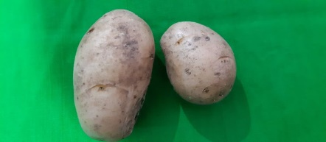 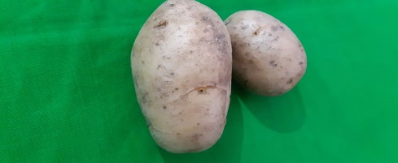 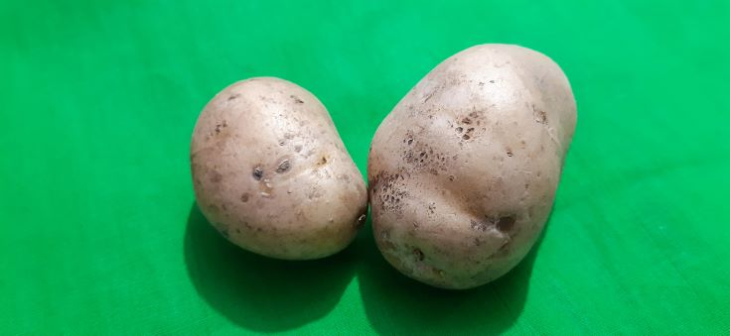 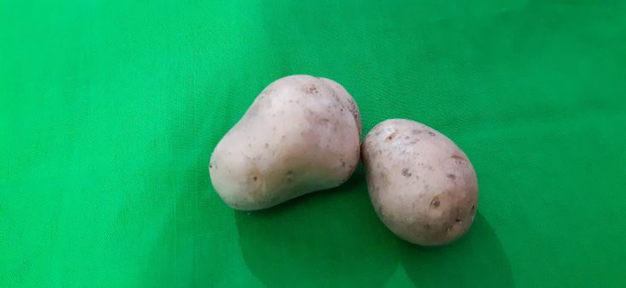

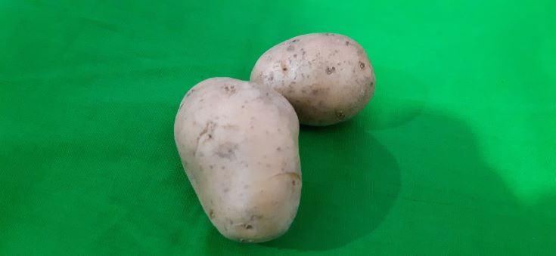 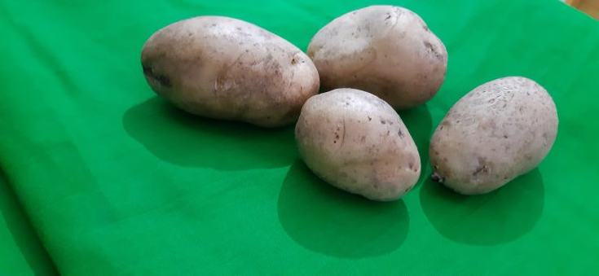 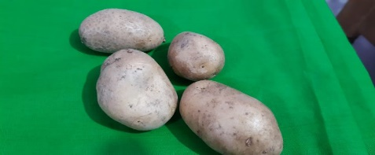

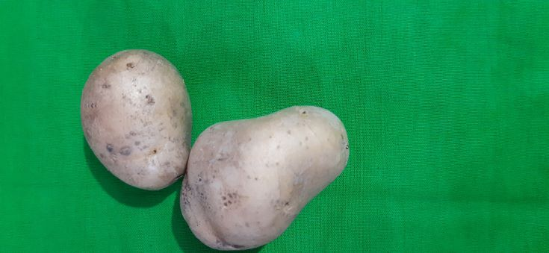

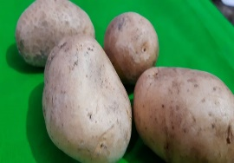 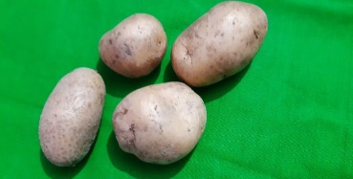 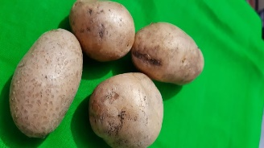 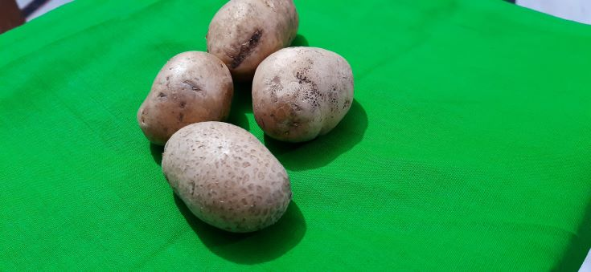

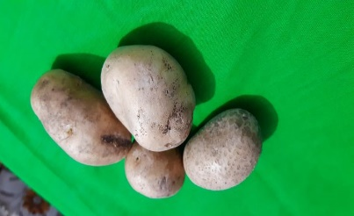 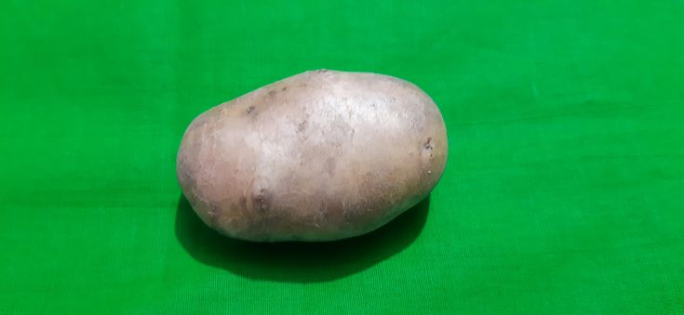 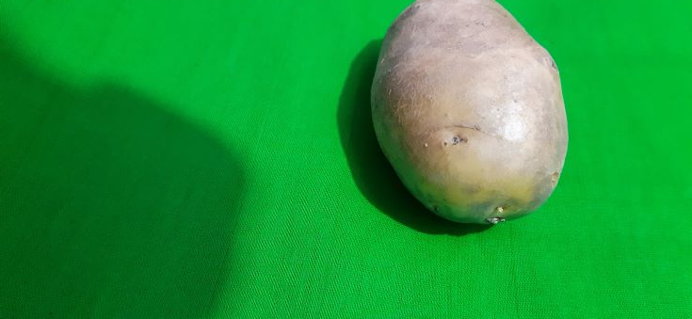 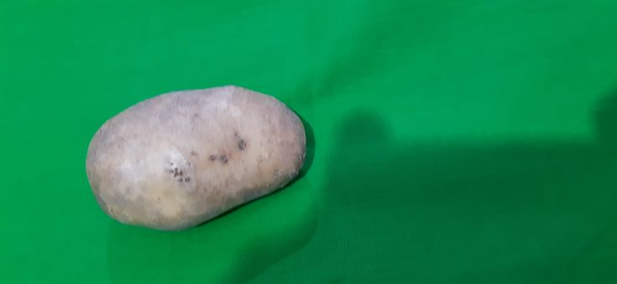

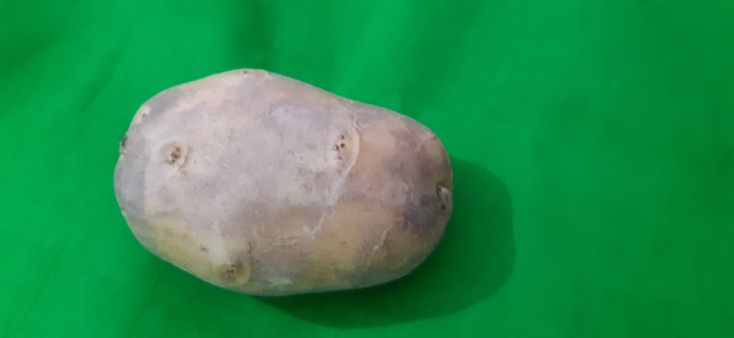 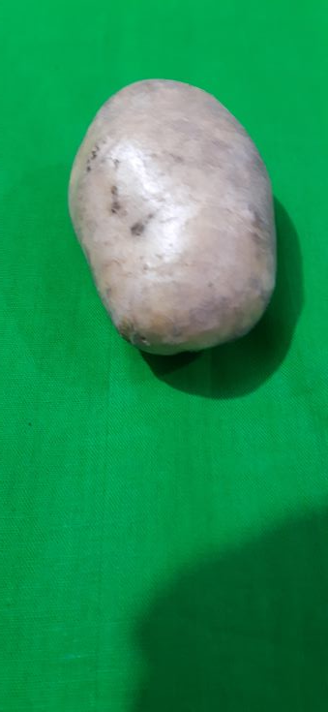 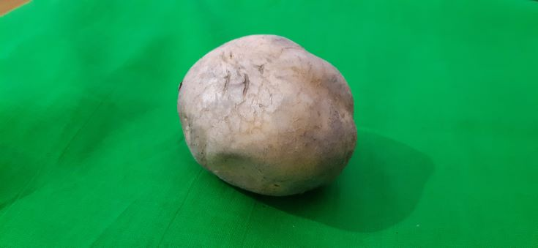 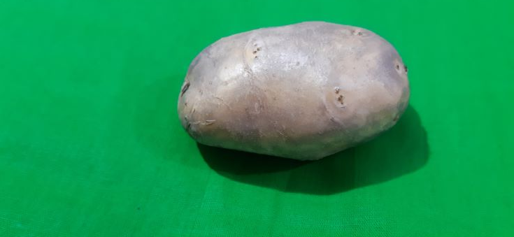

*Figure3.1.1: potato dataset*

(13)

Tomato Dataset (example 20 images):

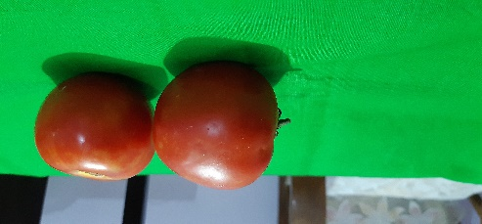 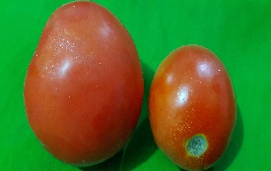 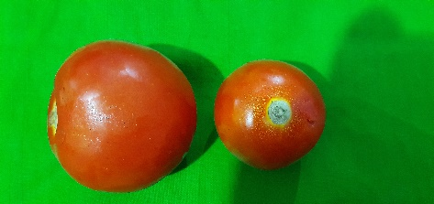

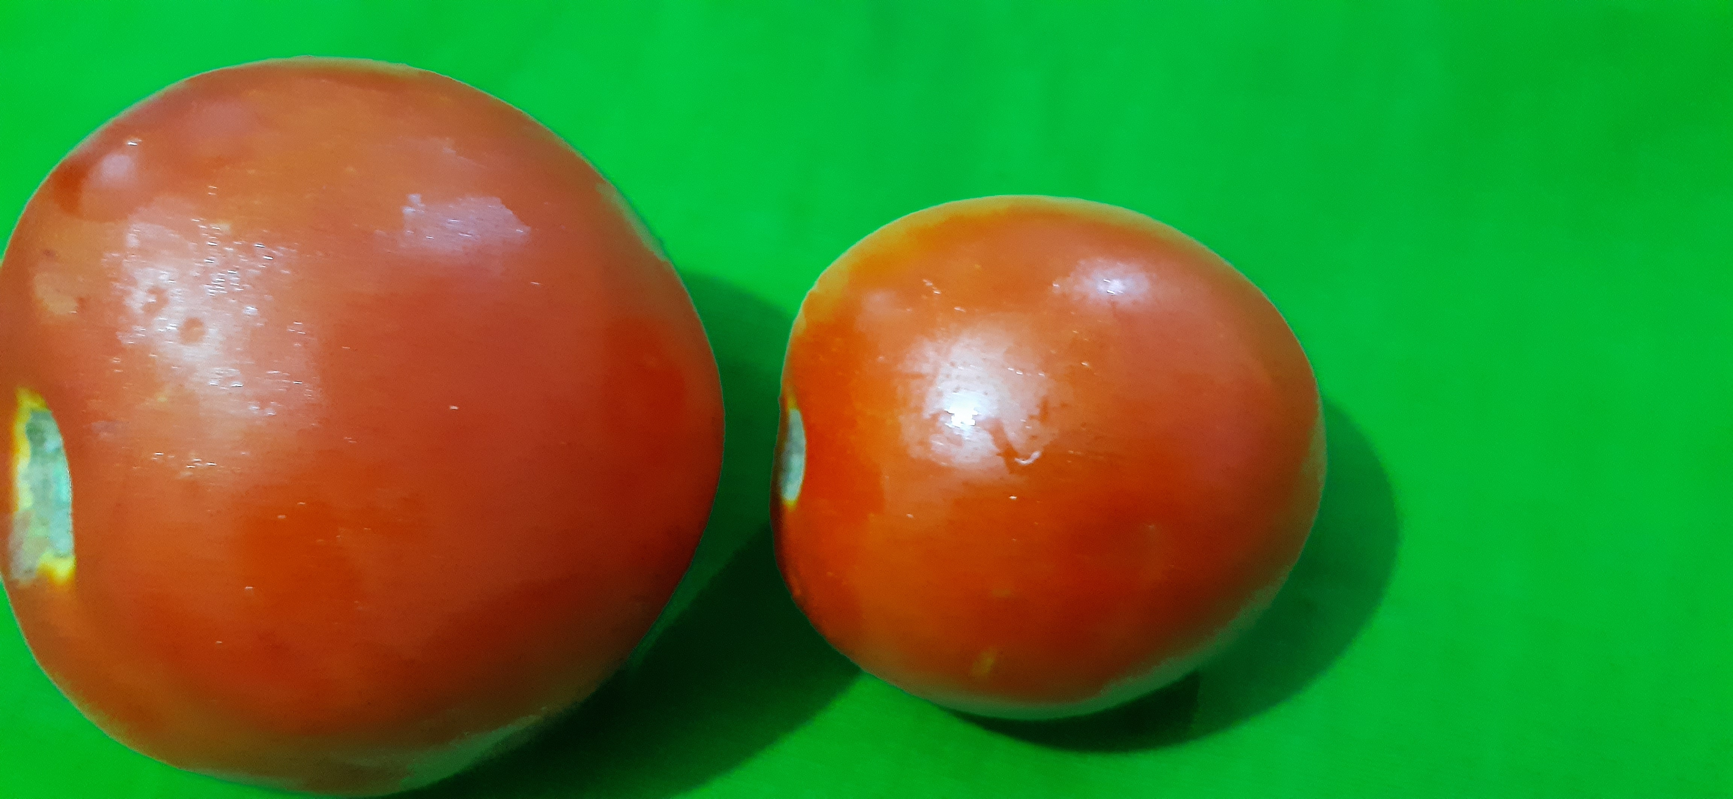

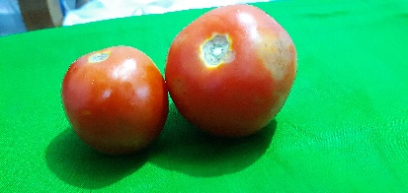 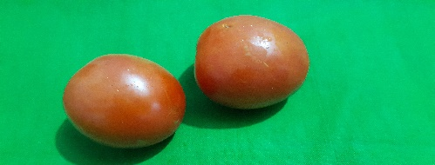 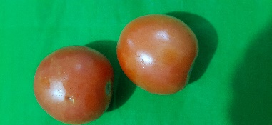

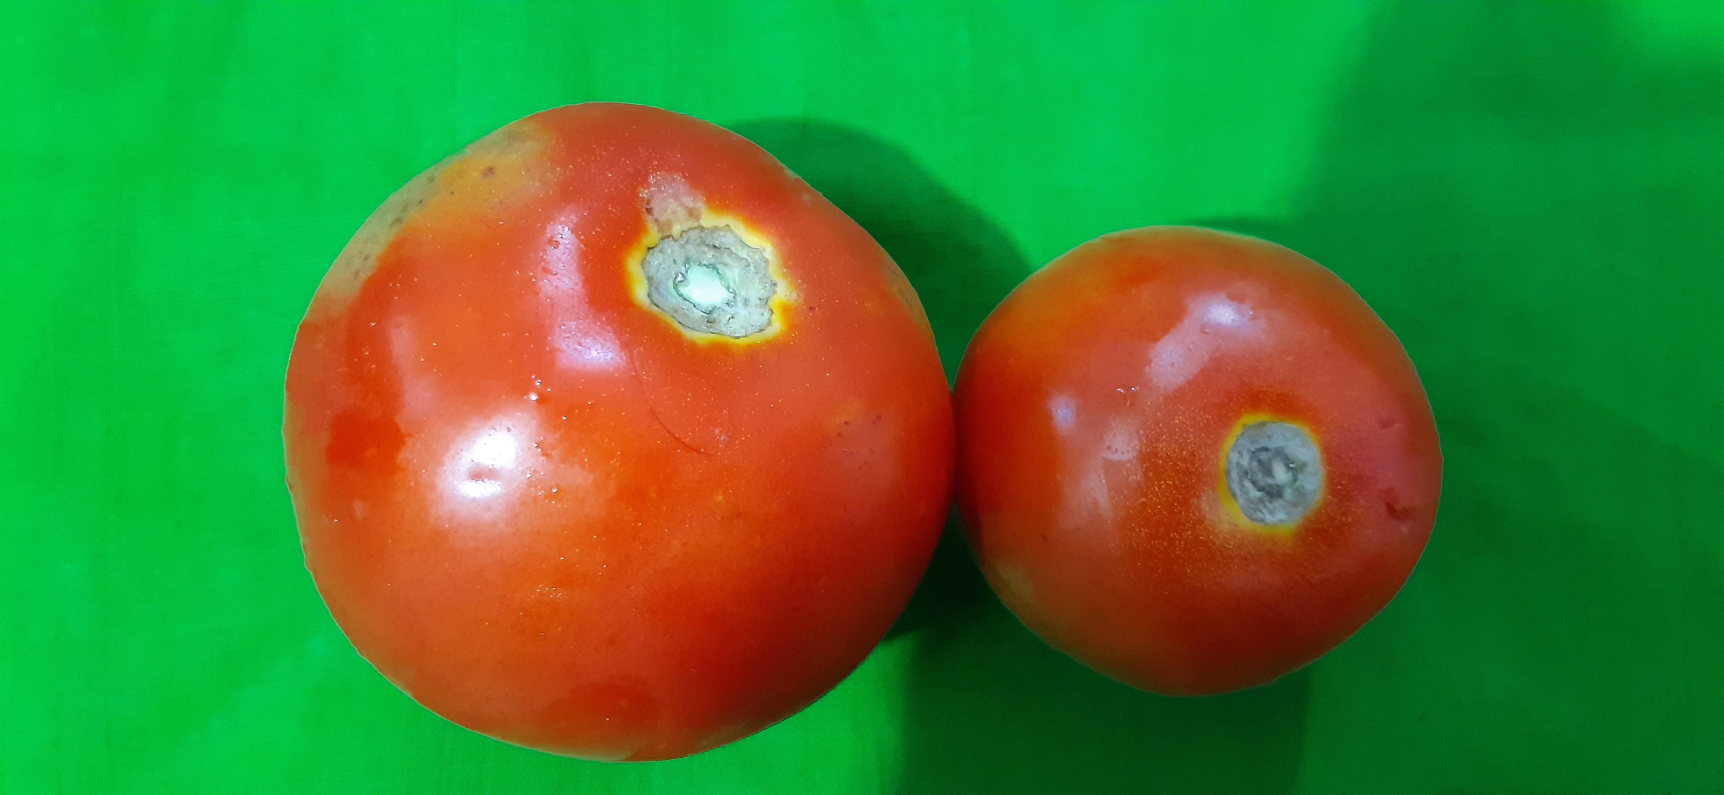

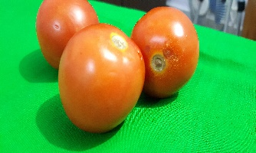

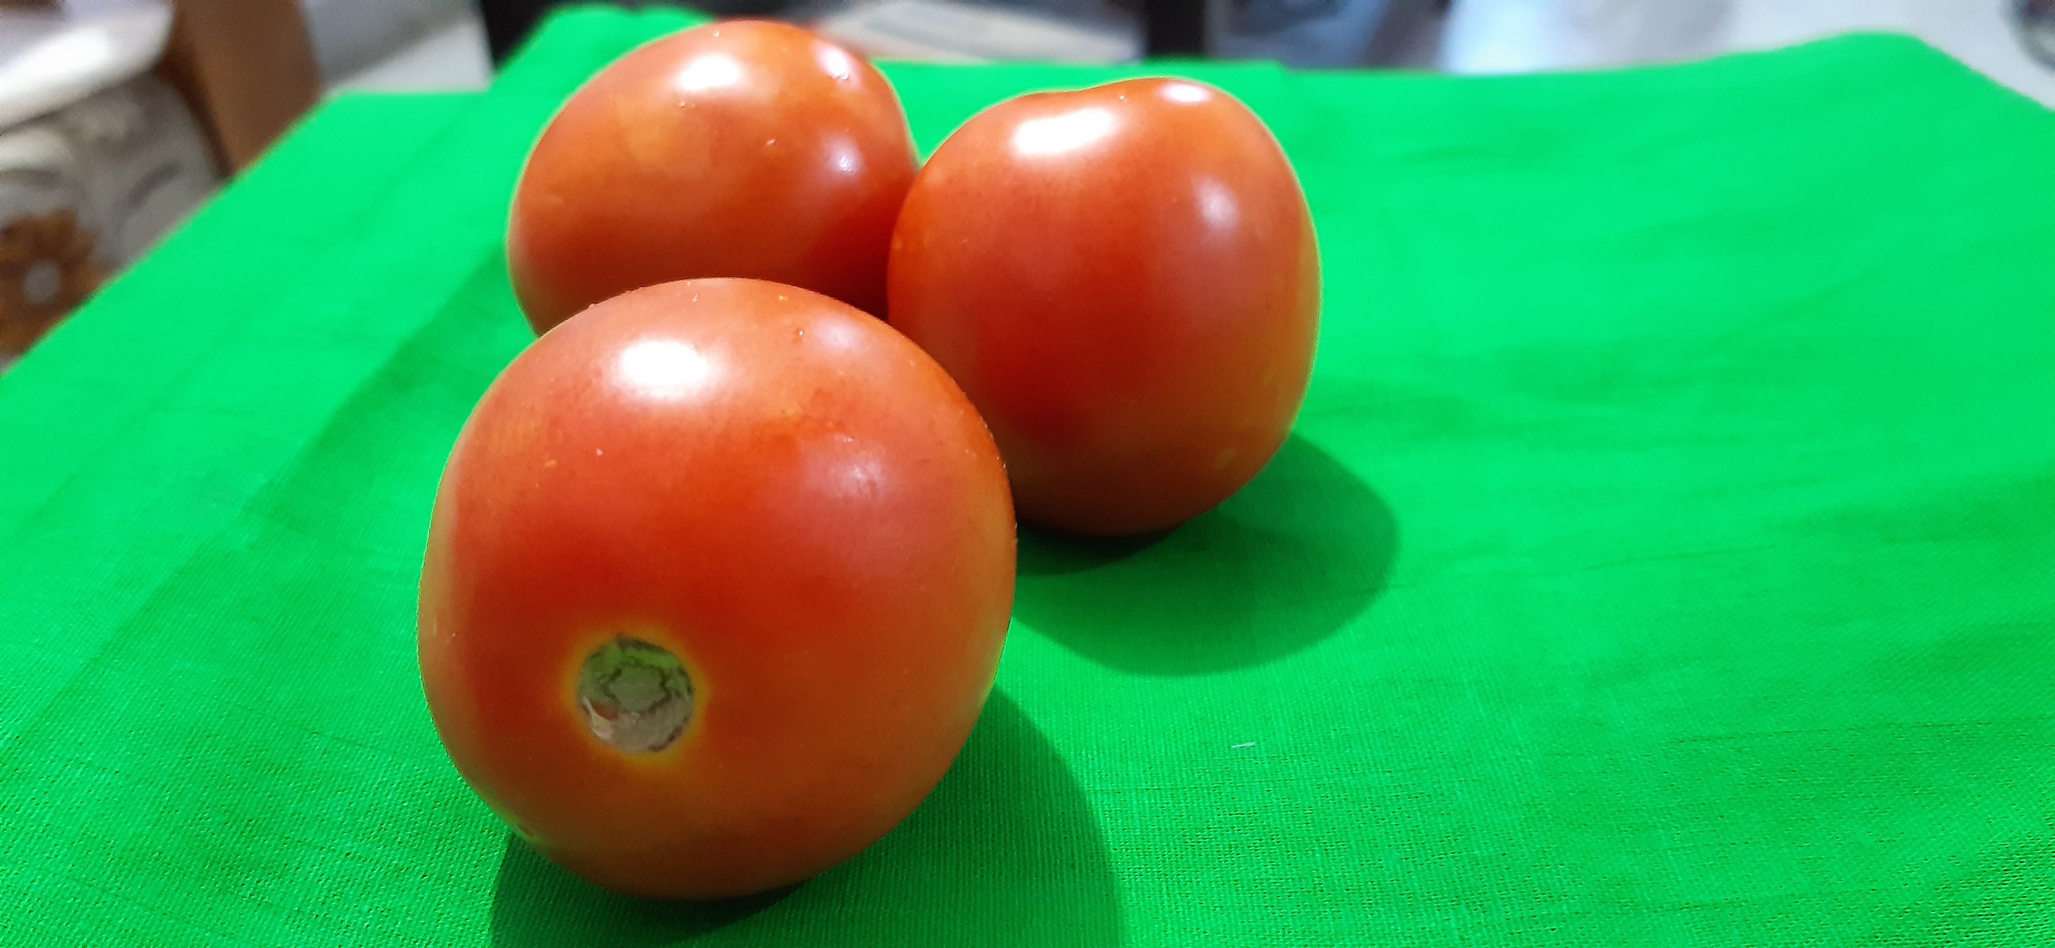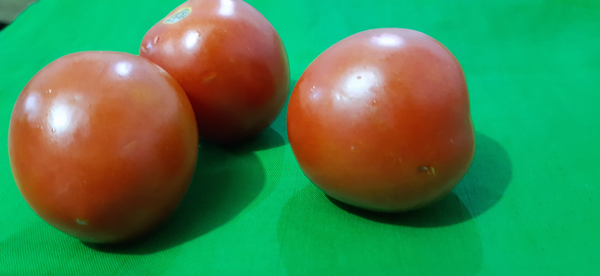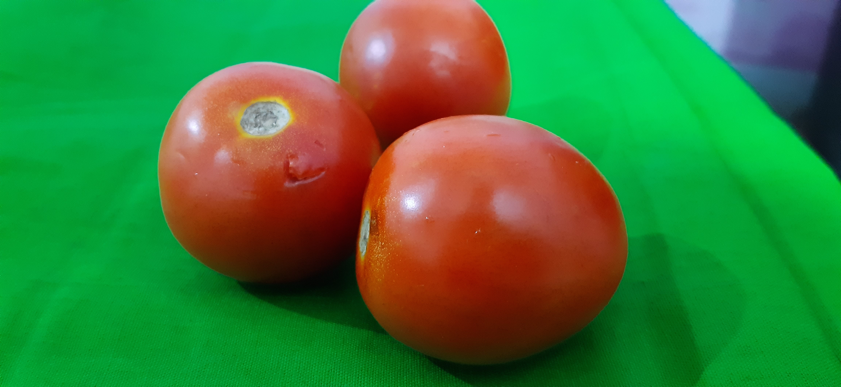

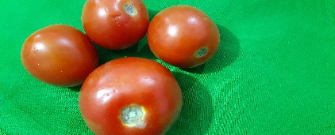 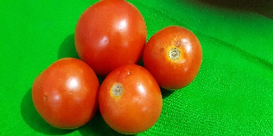

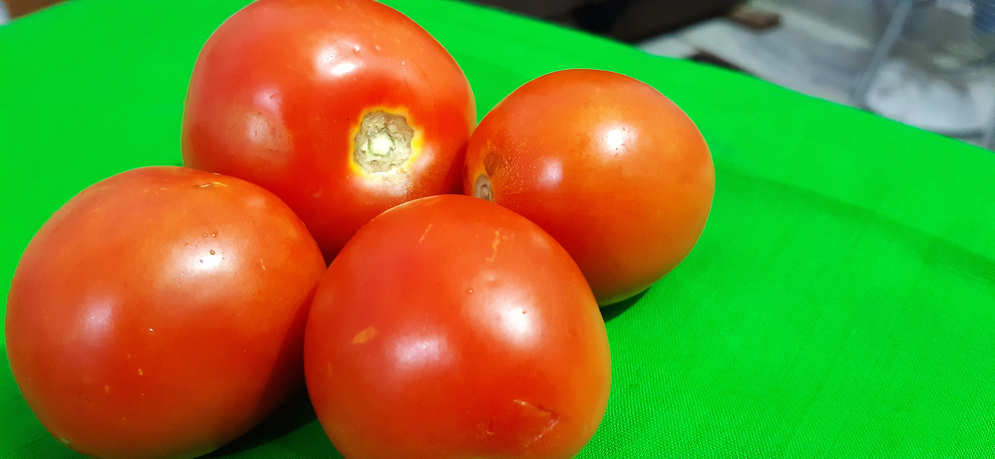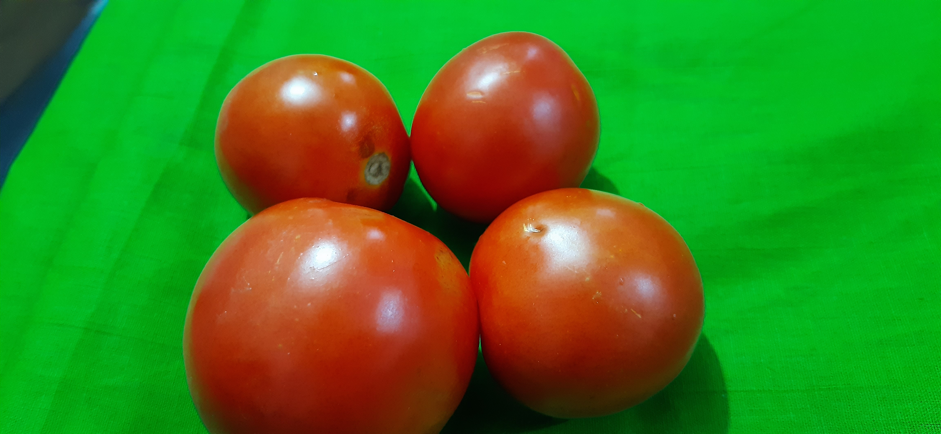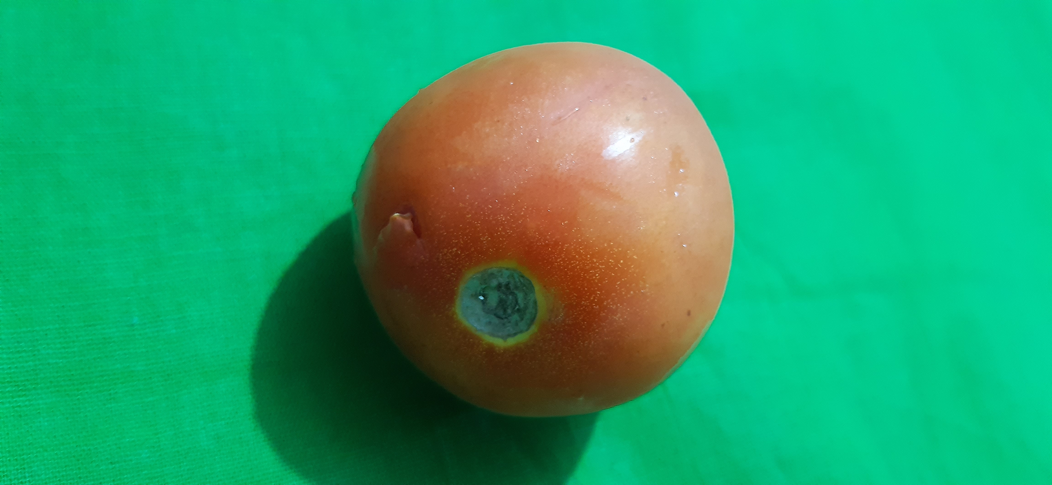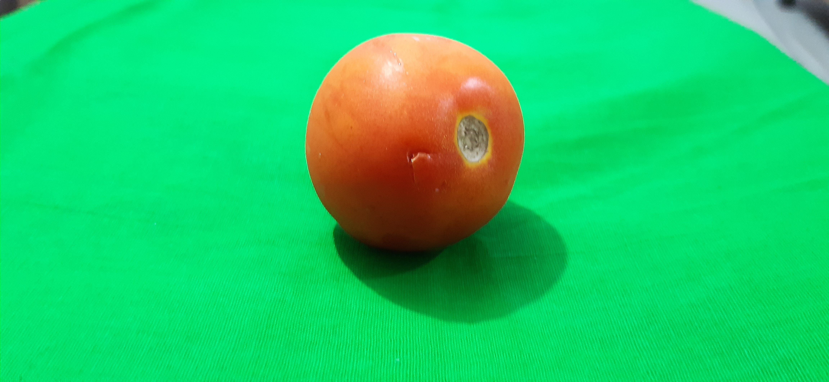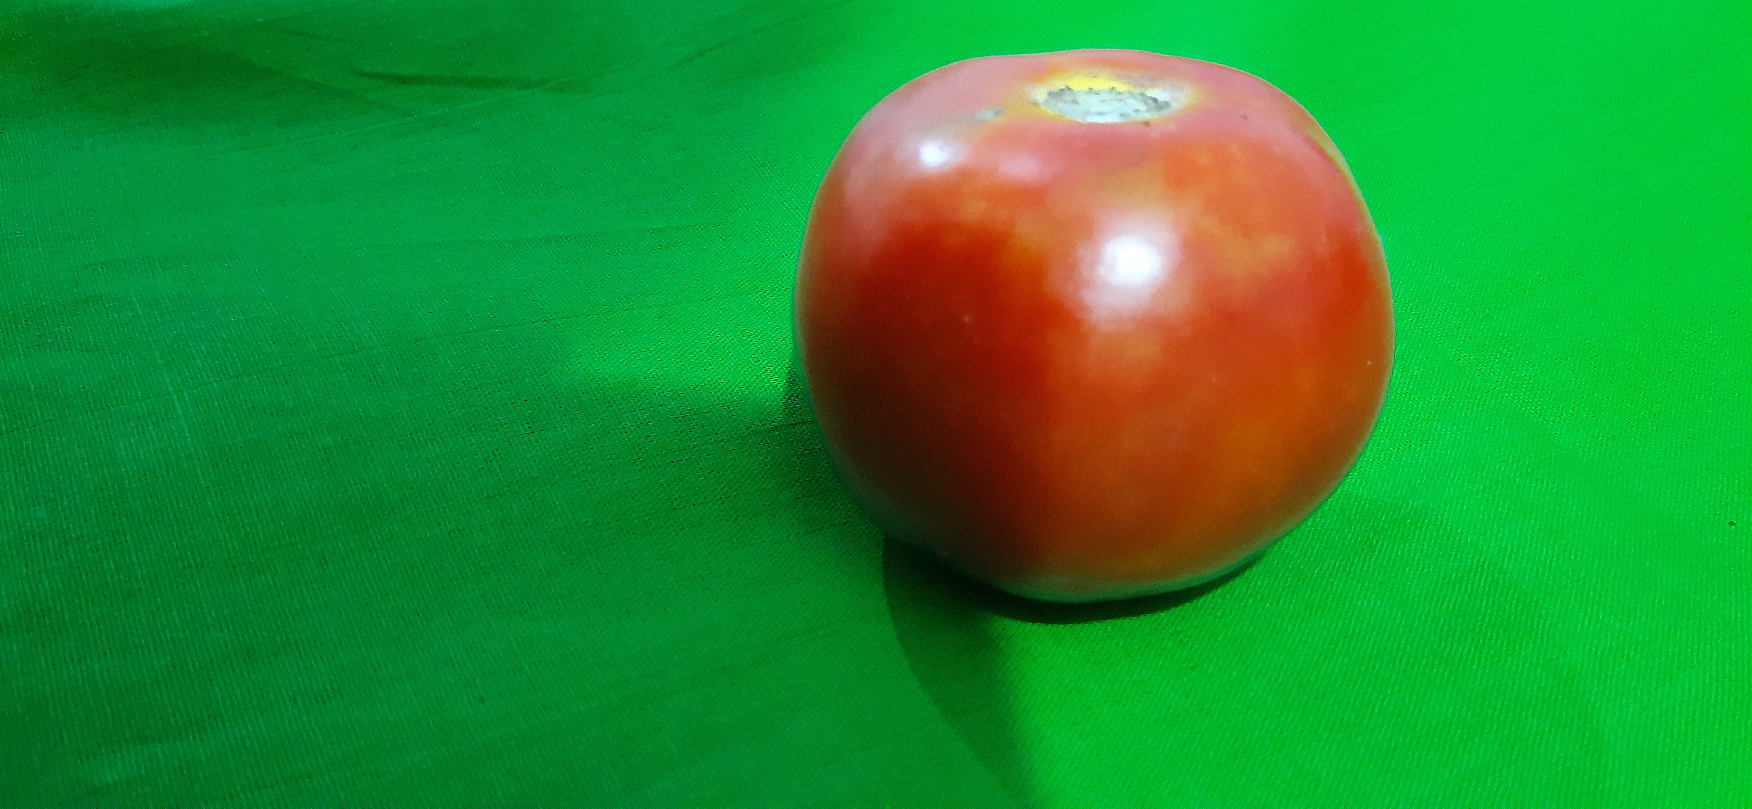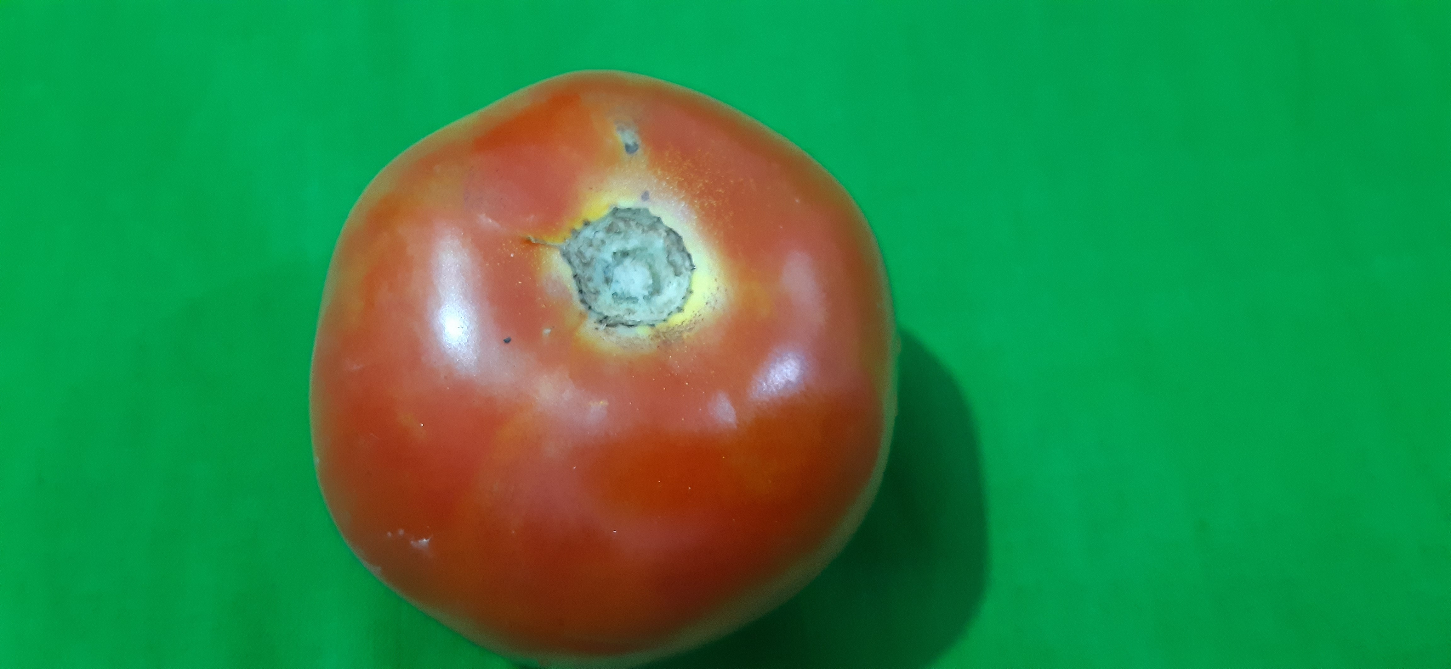

*Figure3.1.2: tomato dataset*

(14)

Onion Dataset (example 20 images):

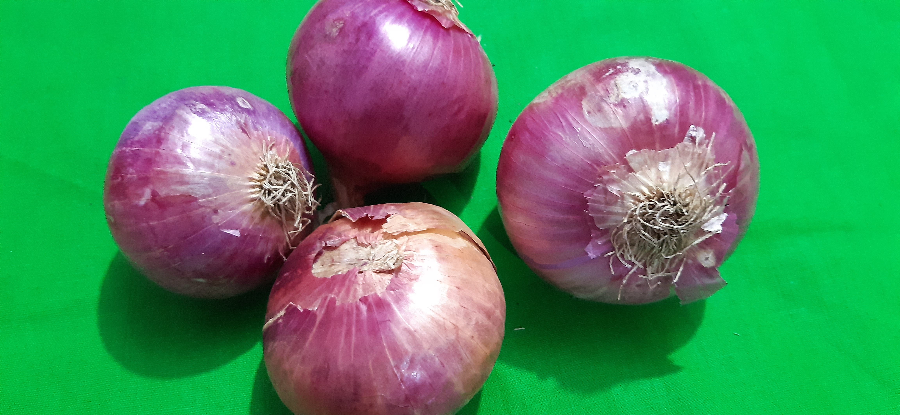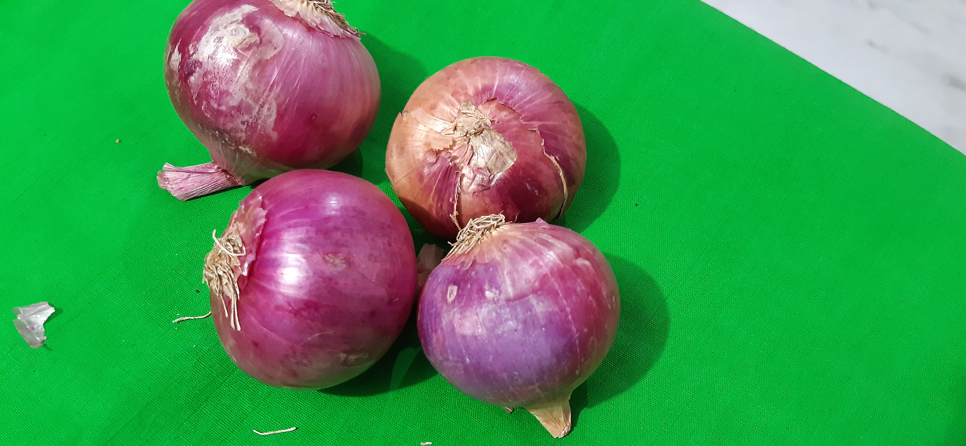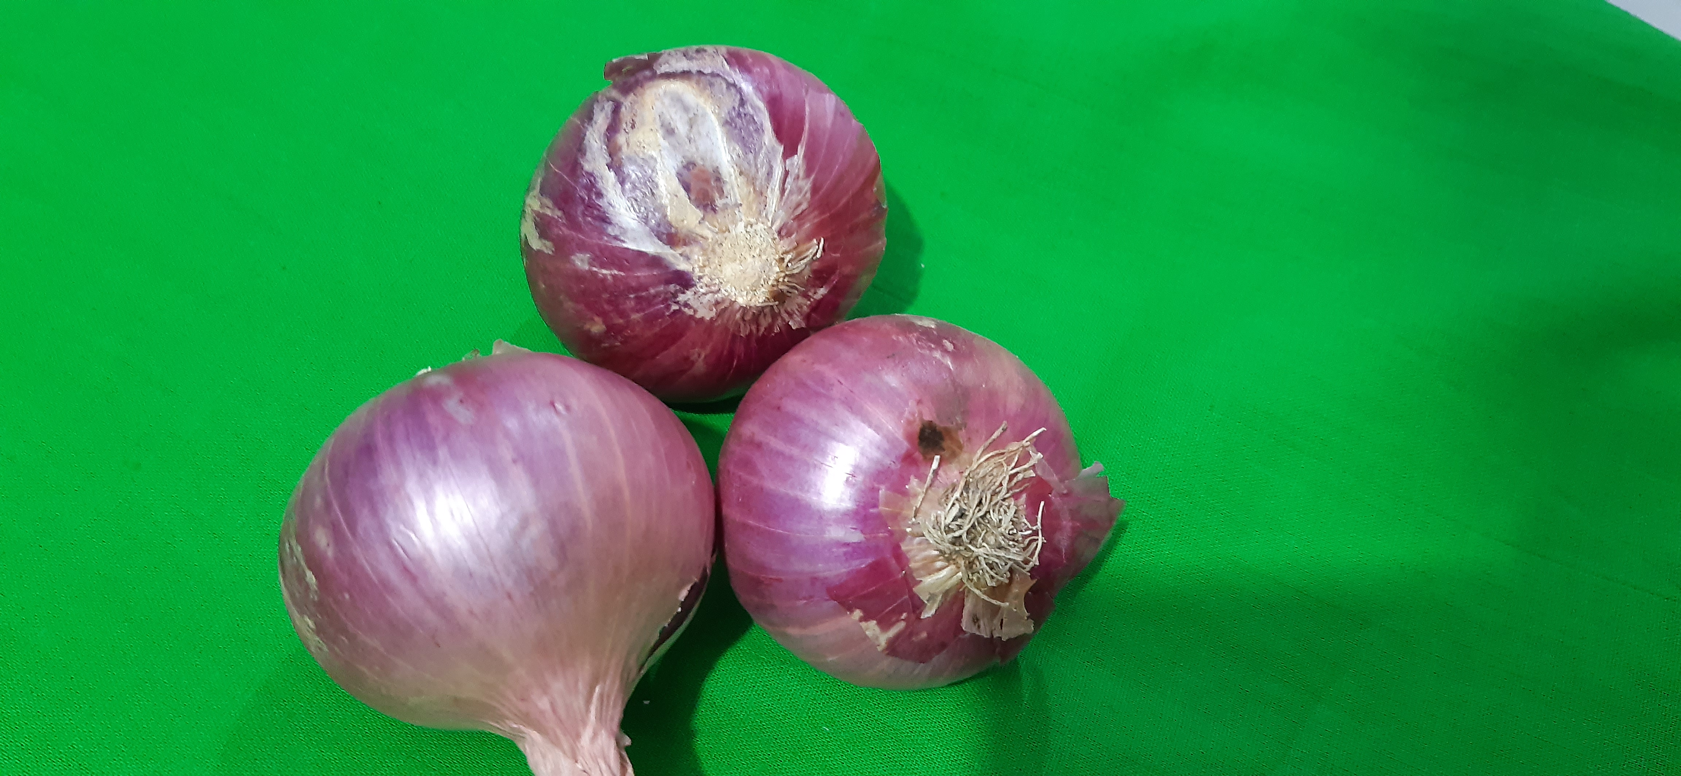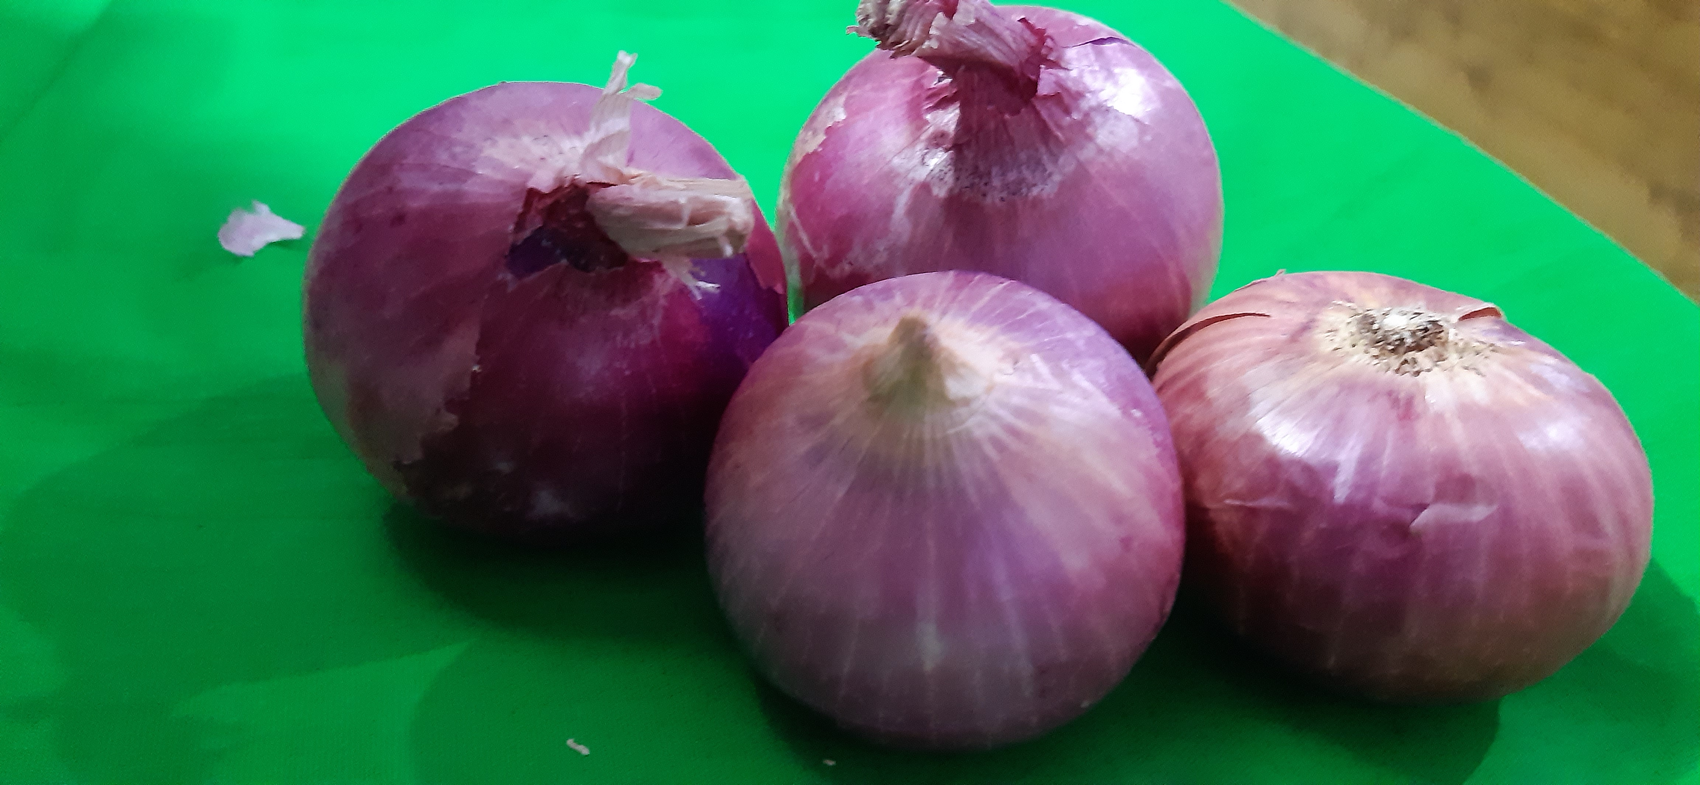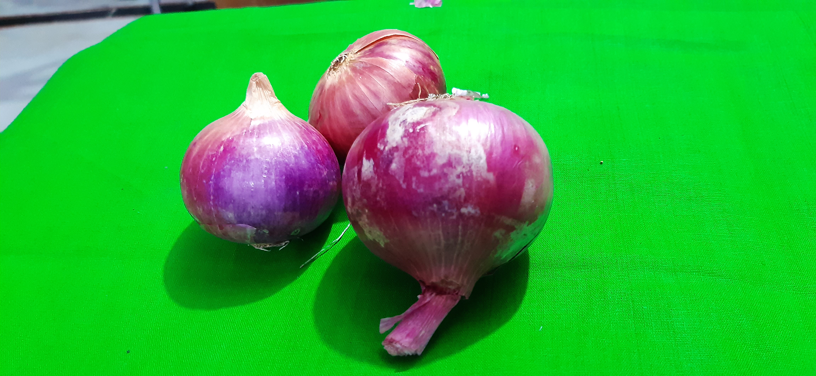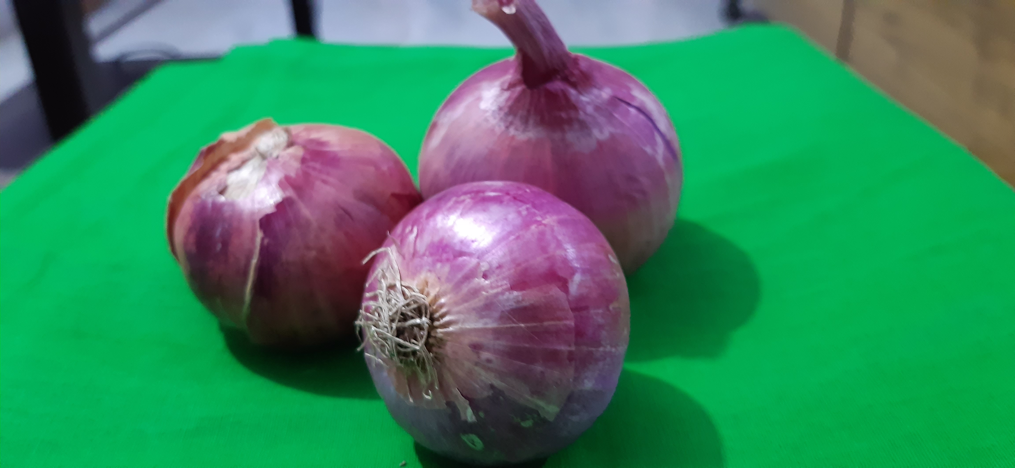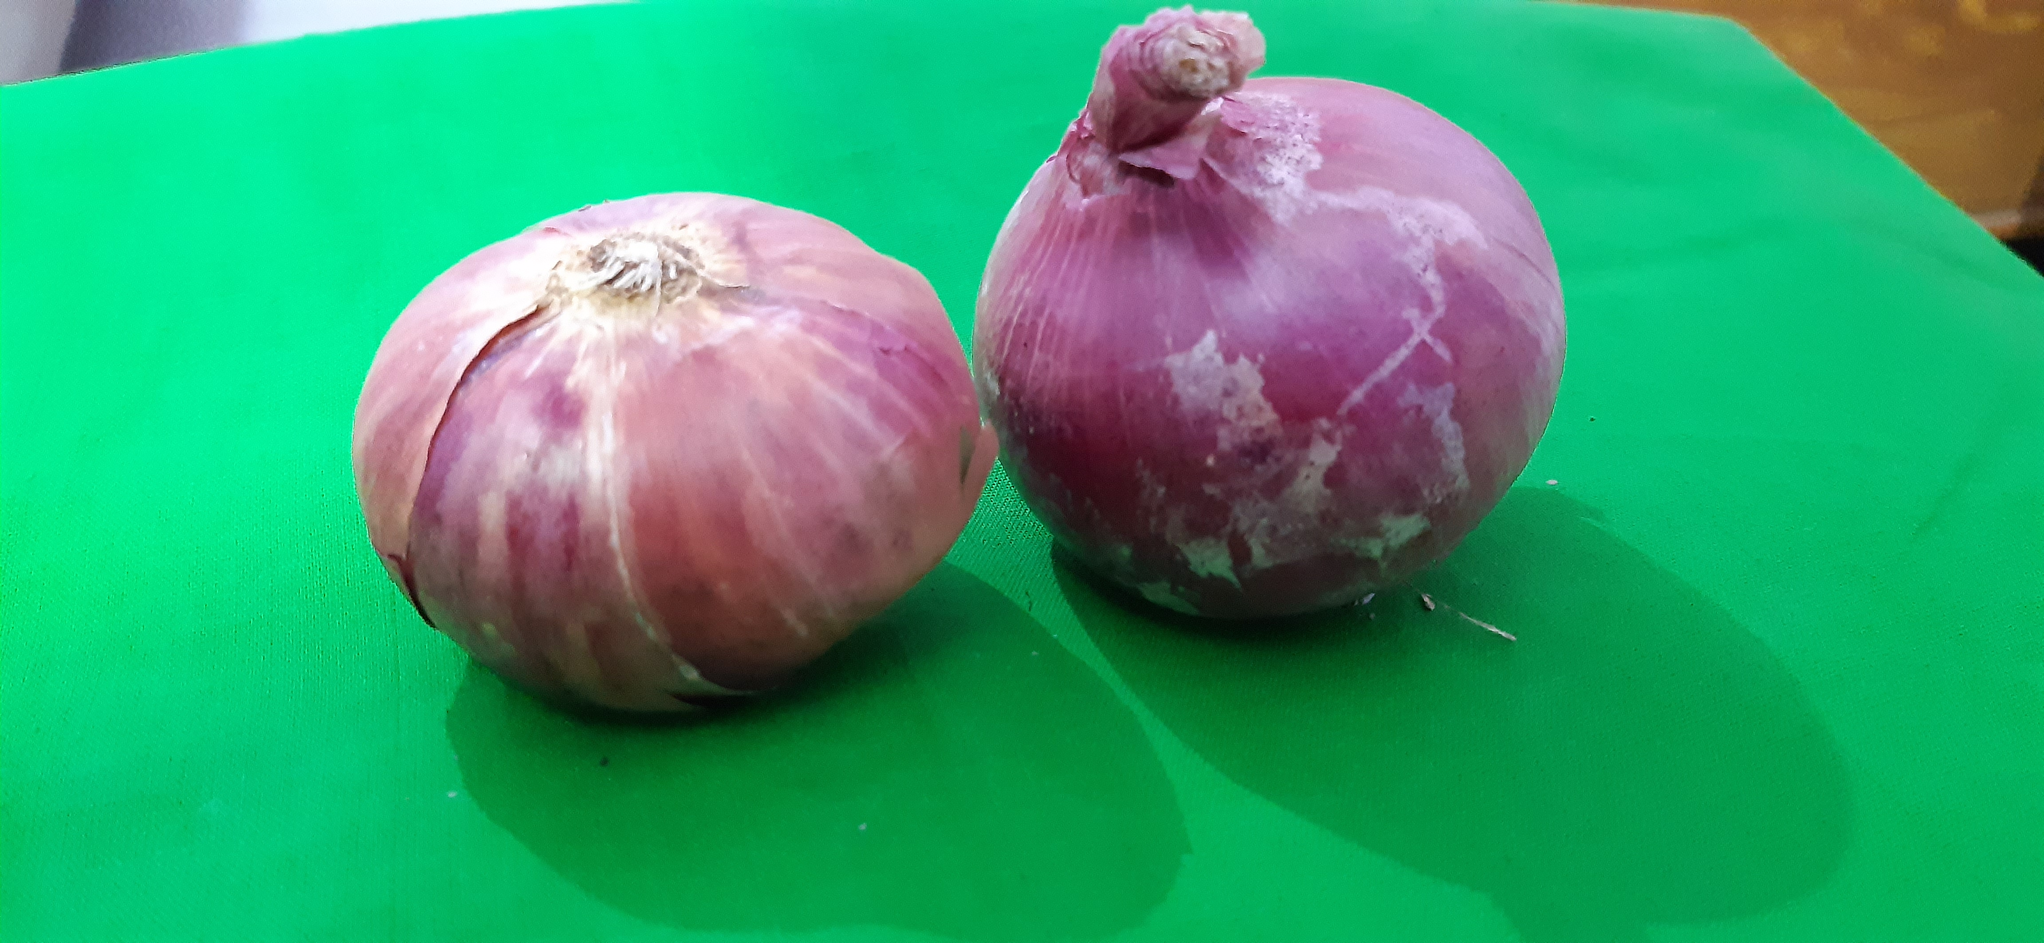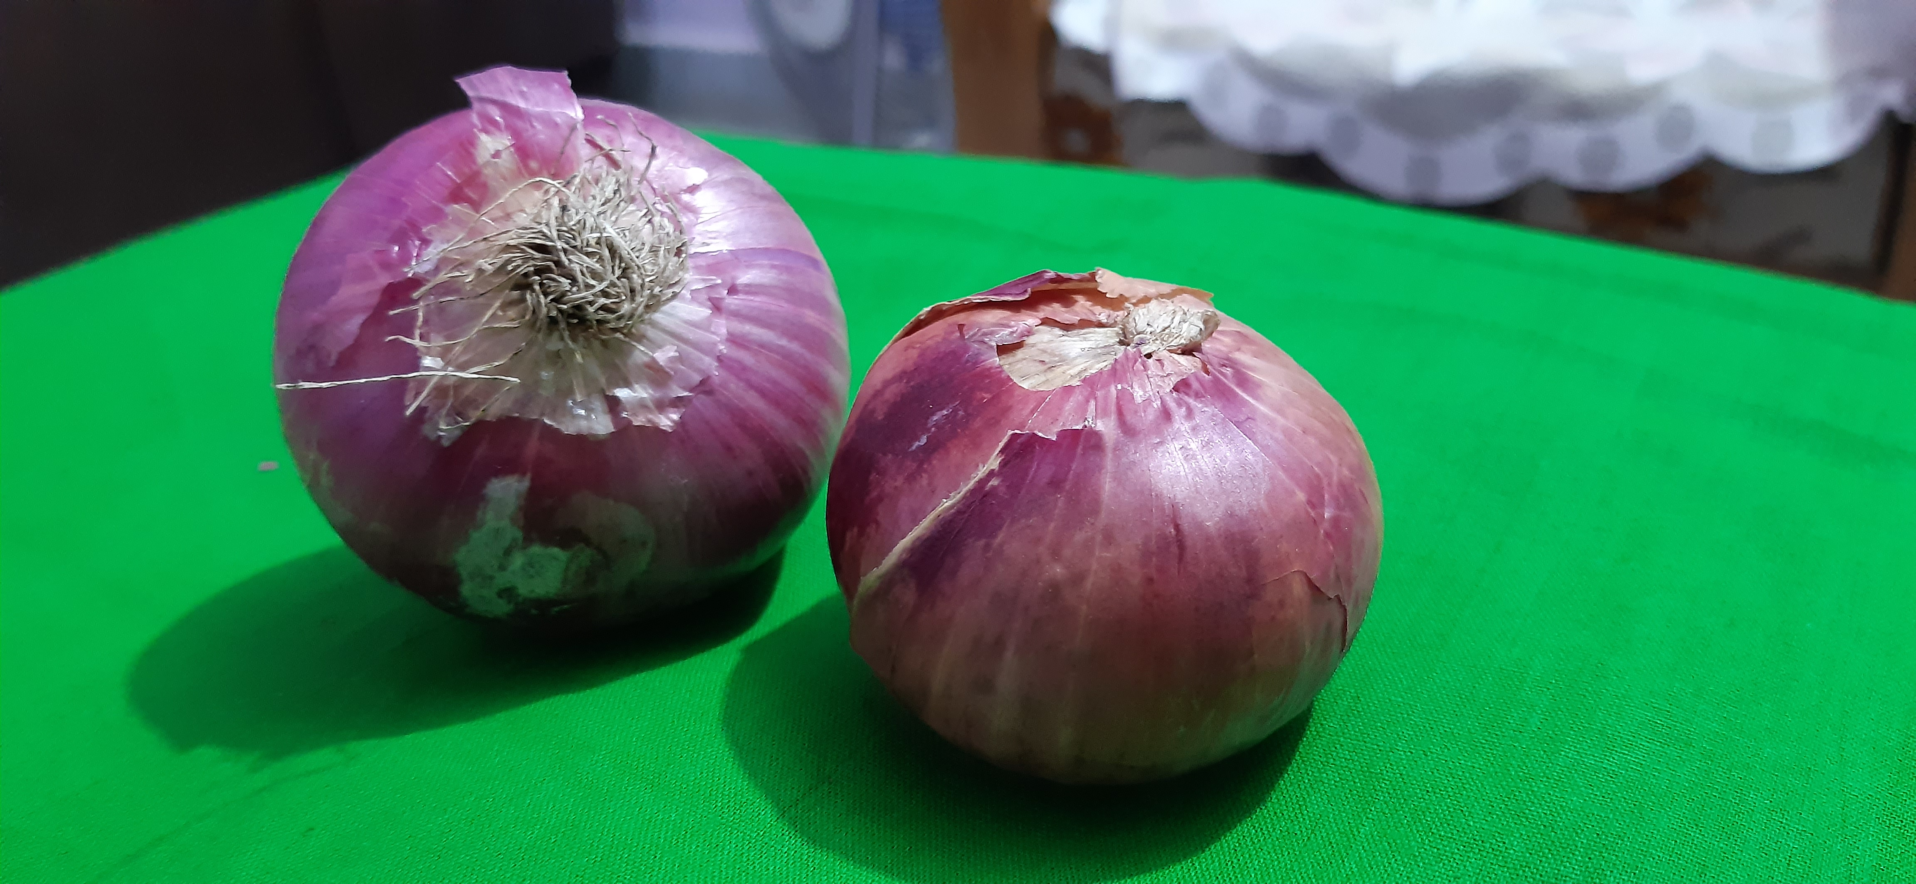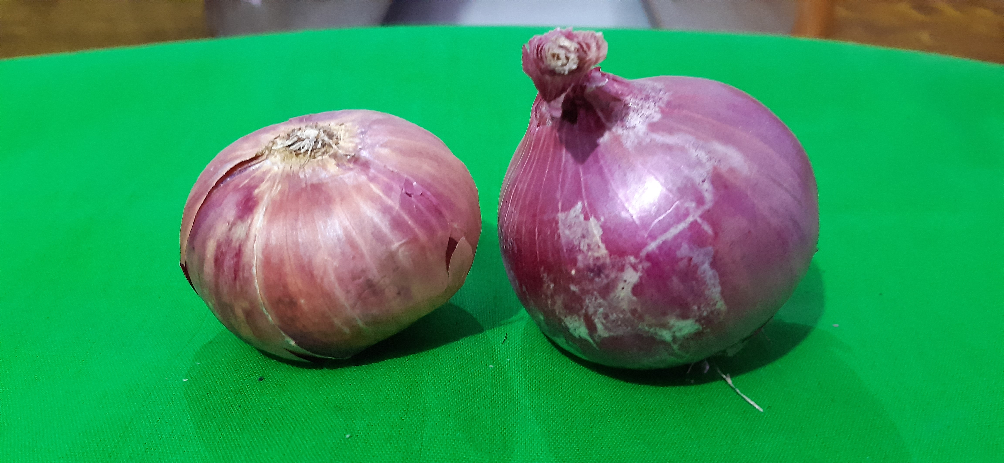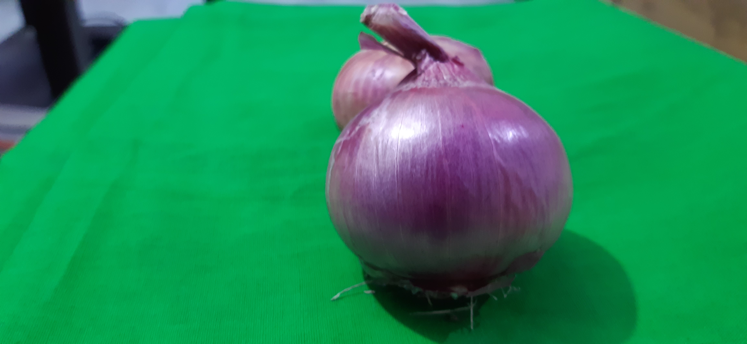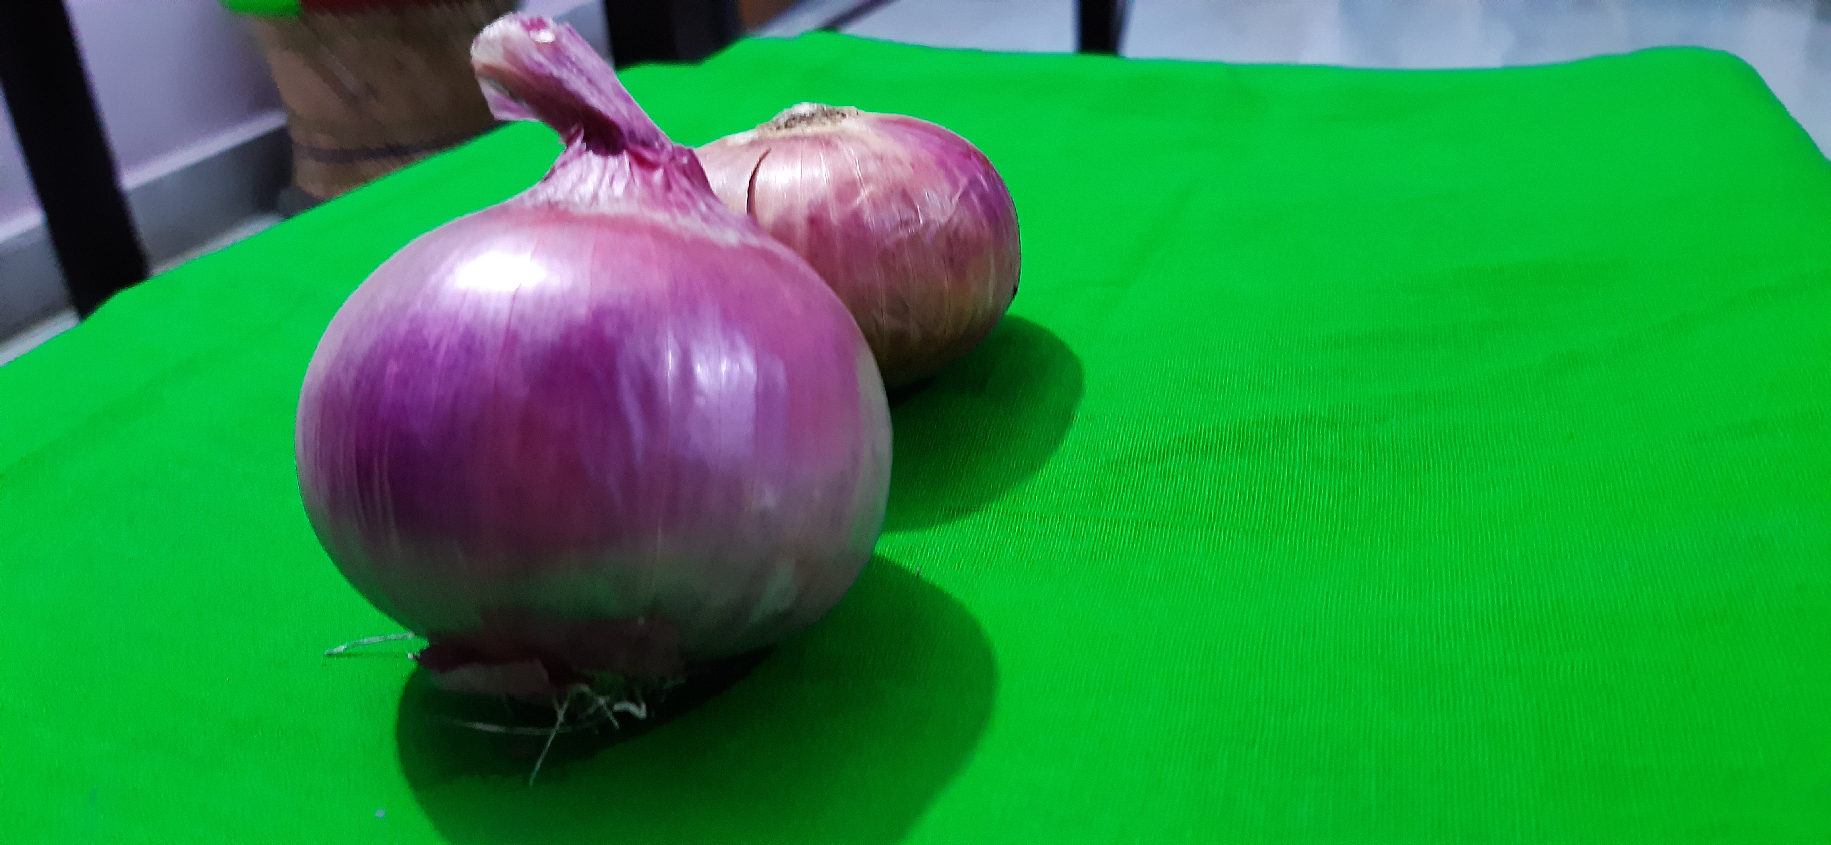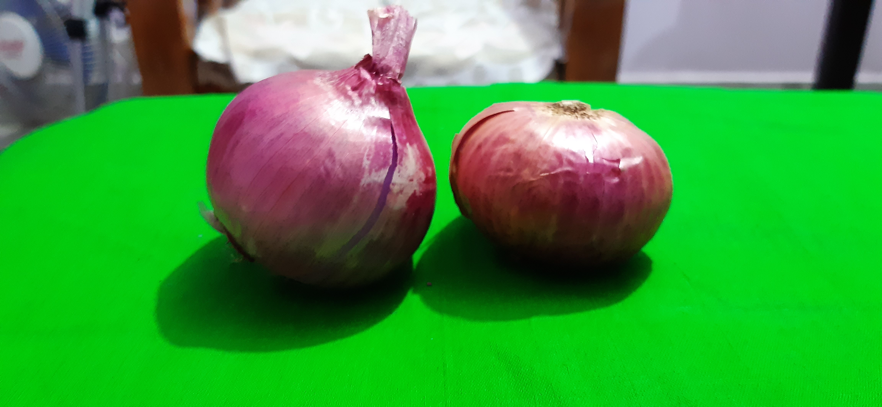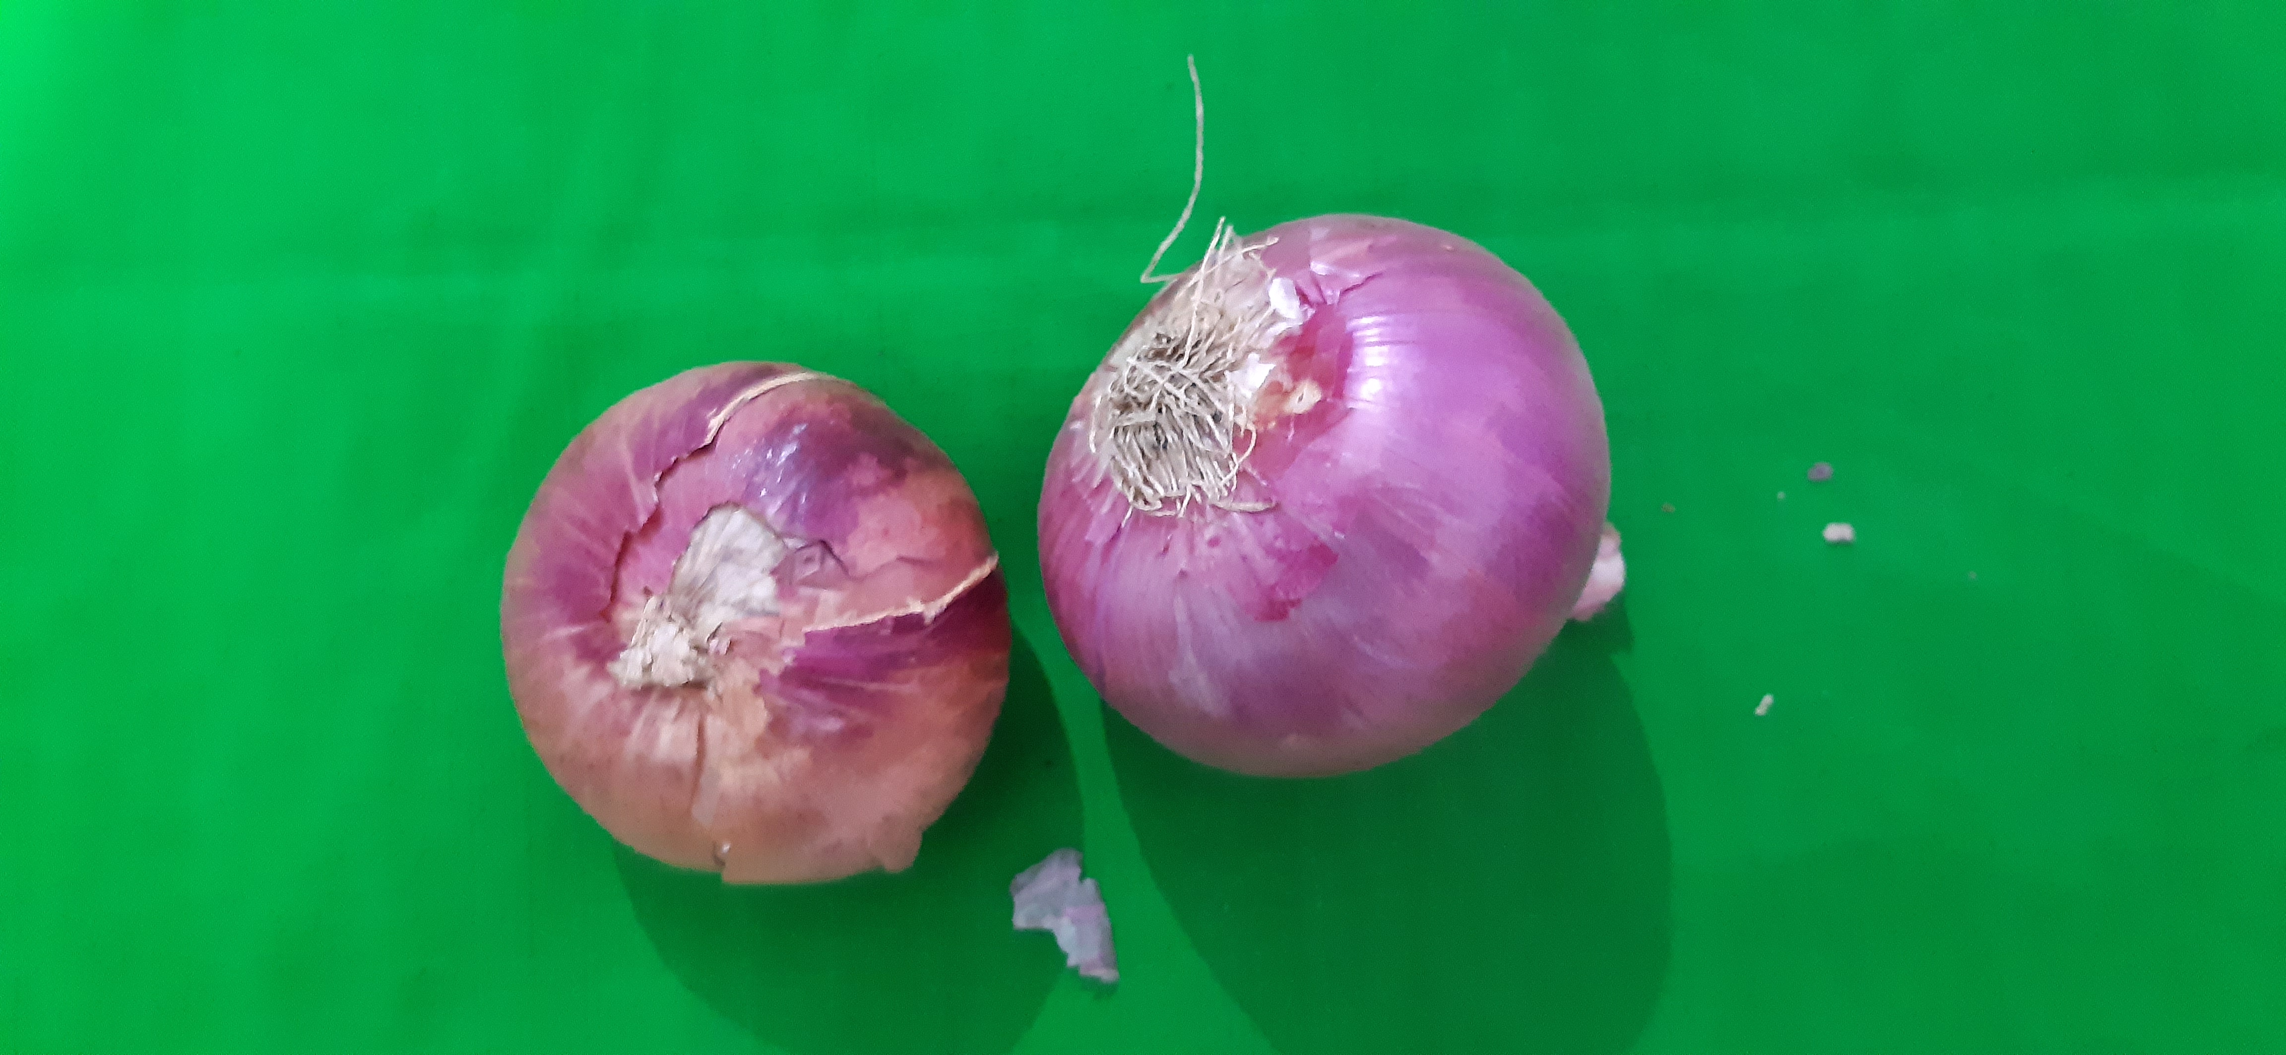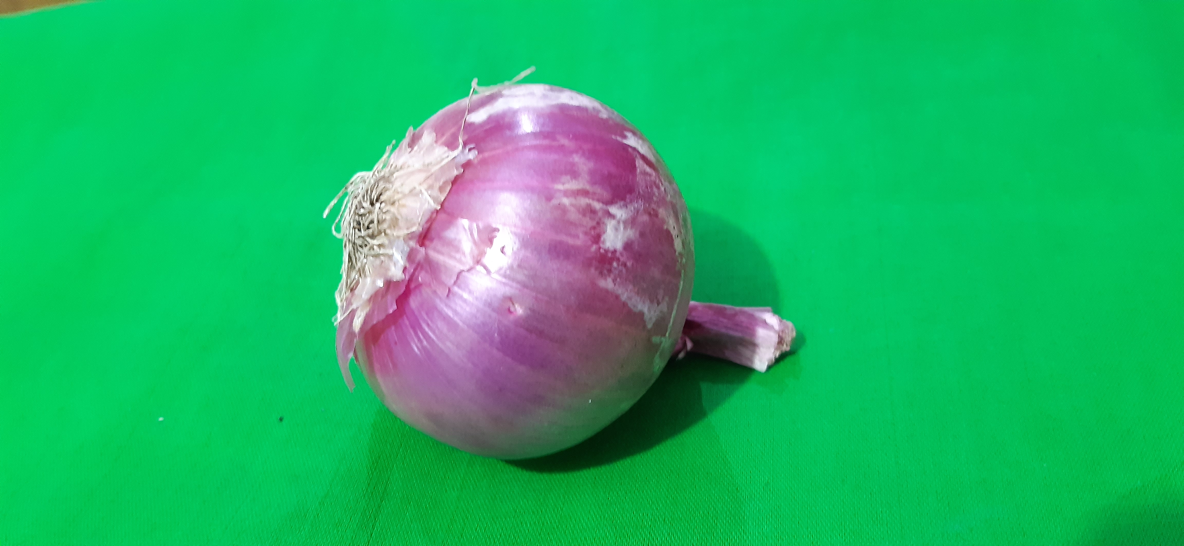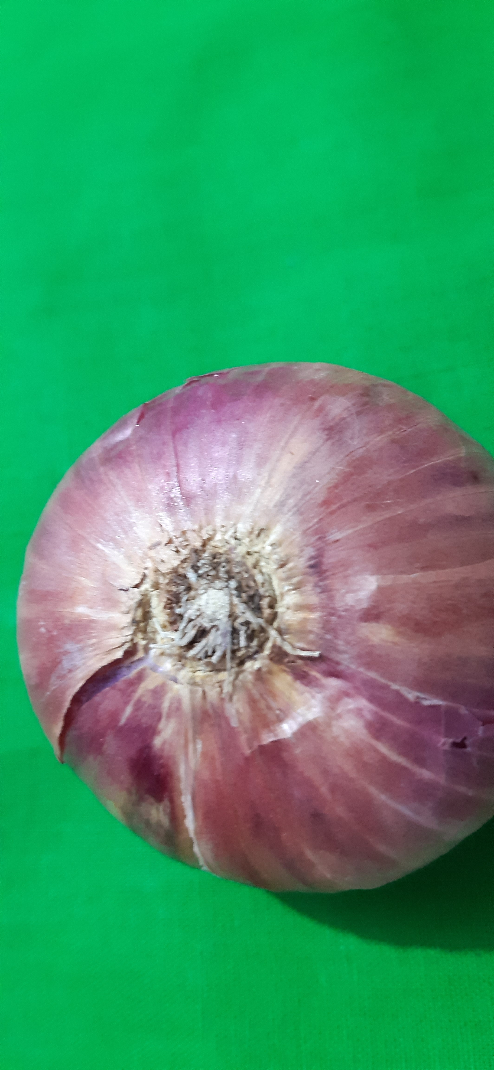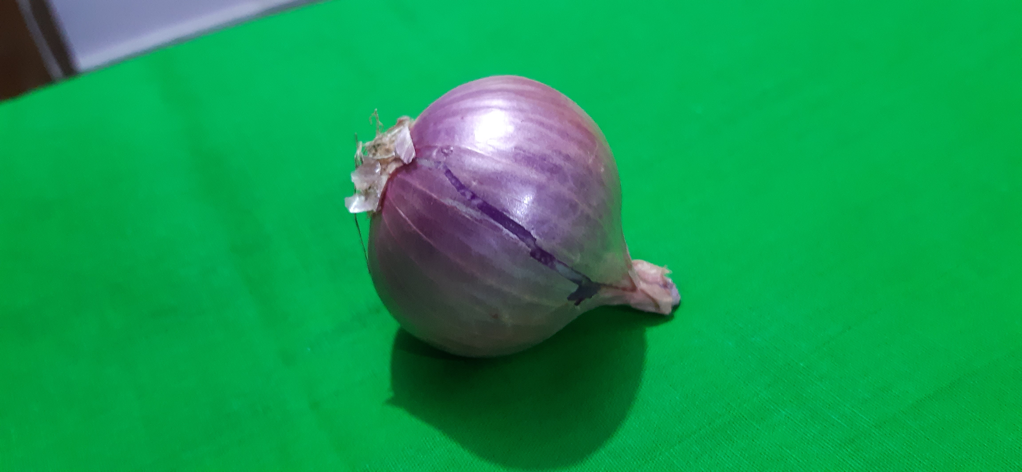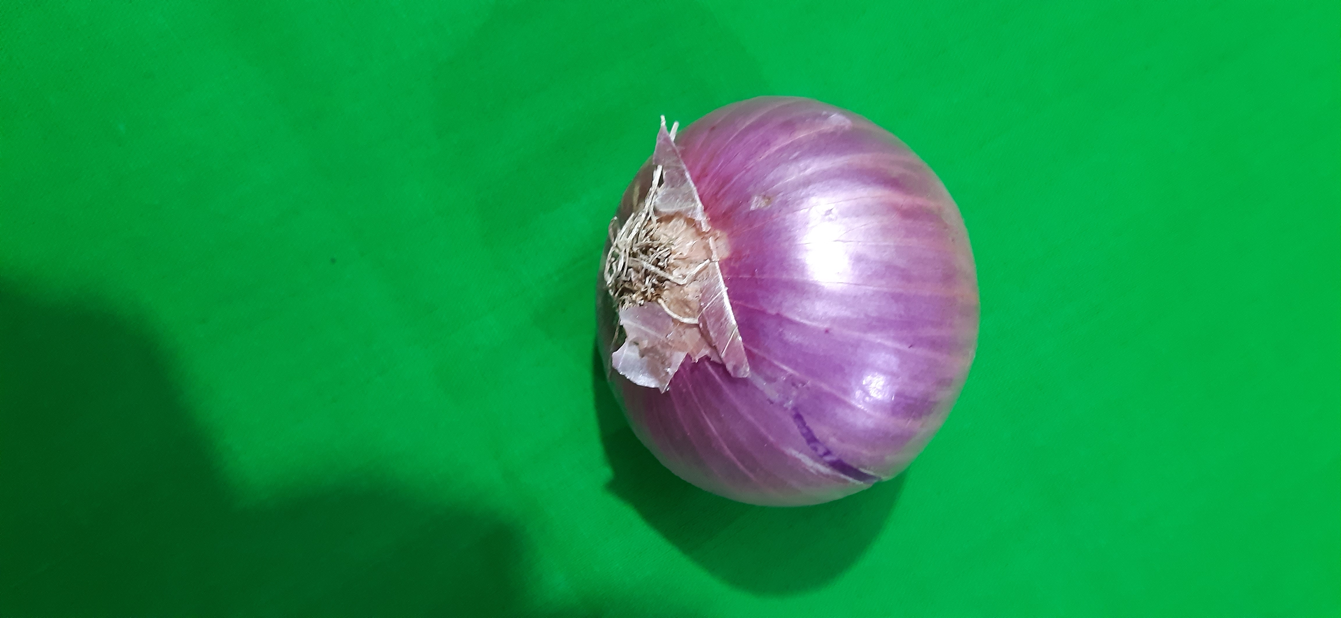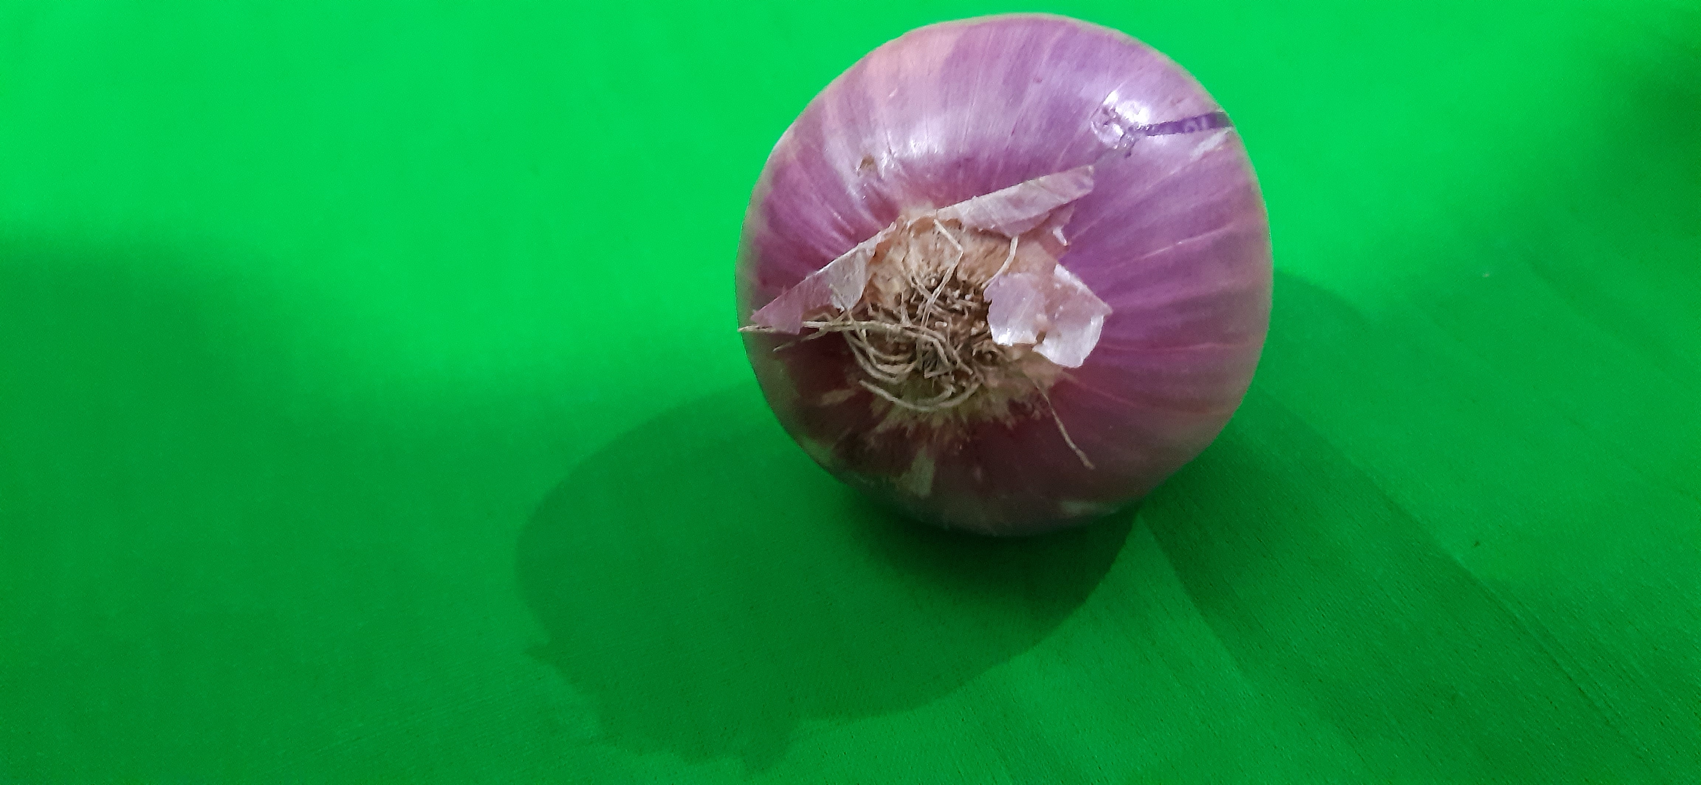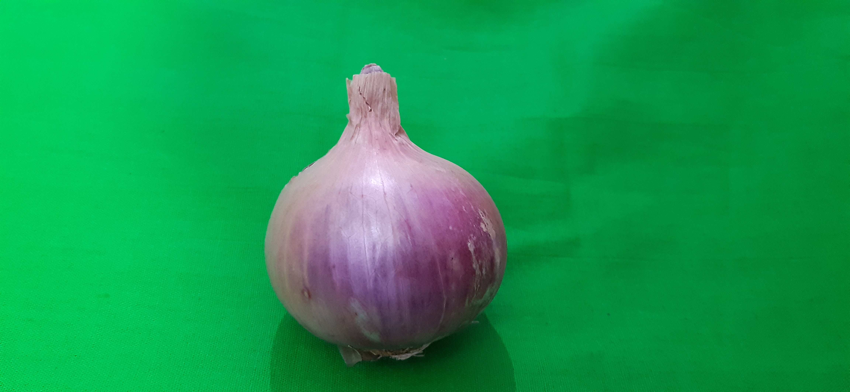

*Figure3.1.3: onion dataset*

(15)

3.2 ALGORITHMS

Before start of machine learning project, data must be loaded into the model. The most common format for machine learning data is CSV files. CSV files are the format in which the data are separated only using commas and hence called Comma-Separated Values (CSV). The python API provides module CSV and function reader() that can be used to load CSV files and then it can be converted to a NumPy array to be used for machine learning.

Algorithms plays a vital role for the in deriving the answers businesses want to derive from the dataset. Choice of algorithm depends on various factors like, data size, quality and parameters, training time and much more. To maximize the efficiency of code, an API (Application Program Interface) is good to be used. Keras follows best practices for reducing cognitive load. It is an easy-to-use Python library for developing and evaluating deep learning projects. We have used Keras here because it offers broad adaptation advantage and support for multiple GPUs and distributed training. The neural networks have two main hyperparameters that control topology of the model: the number of layers and the number of nodes in each hidden layer. A single-layer network can be extended to a multi-layer network or multi-layer network is a neural network with more than single layer. Input layer contains input variables and called as visible layer, Hidden layers are the nodes between input and output layers and it can be more than one in number. The output layer of nodes are that layer which produces output. Multi-layer network is capable for the model with nonlinear separable functions. Keras is one of the best high-level neural network APIs. It is a Python library and written in Python in too. It supports multiple back-end neural network computation engines. In TensorFlow, using the high-level Keras APIs, tf.keras. Keras Conv2D is a 2D Convolution Layer that creates a convolution kernel that is wind with layers input which helps produce a tensor of outputs. Kernel is a convolution matrix which can be used for sharpening, edge detection and more by doing a convolution between a kernel and an image.

(16)

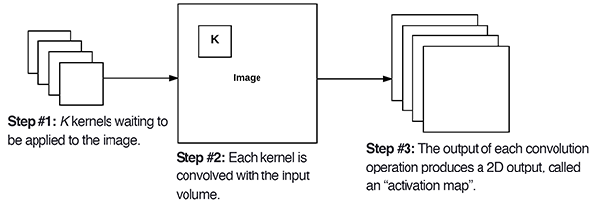Figure3.2.1: Keras Conv2D parameter

Numbers of filters that convolution layer will learn from is the mandatory Conv2D parameter. It also determines the number of output filters in the model.

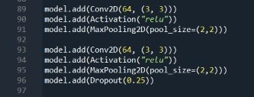

Figure3.2.2: code for Conv2D

Here in figure3.3.2 on 89th column, we are learning a total of 64 filters and then we use Max Pooling to reduce the spatial dimensions of output volume. The kernel dimension is represented as (1, 1) for 1x1 and (3, 3) for 3x3, It is just the height and width of the 2D convolution matrix. It is always an odd integer. The activation parameter allows to supply a string, specifying the name of activation function to apply after performing the convolution.

Pooling the layers helps in summarizing the presence of features in patches of the feature map and the most common pooling method is MaxPooling. It calculates the maximum value in each patch of each feature map. The maximum pooling operation can be added to machine learning models by adding the MaxPooling2D layer provided by Keras API. See figure3.3.2.

(17)

3.3 RESULT AND DISCUSSION

In this project, a convolutional neural network on the dataset is applied in order to perform a better classification of the network. Hidden layers and Pooling are used in combination with the total of 25 epochs with total of 4 Convolutional Layers. Epochs can be defined as the number of passes of entire training dataset the model has completed. In other words, it is the iterations. The most common method for training of data in deep learning is a gradient descent and hence multiple epochs are needed for deep learning. Model loss and model accuracy are calculated with help of Python libraries. TensorFlow library in Python is used to obtain the accuracy and MatplotLib library is used to obtain the graph to depict the accuracies. MatplotLib library is for 2D plots of arrays. It is a data visualization library built on NumPy arrays and contains several plots like line, bar, histogram etc.

The goal of training a model is to find a set of weight that have low loss, on average, across all examples. The model loss graph depicts how bad the model’s prediction was on a single training, *graph 3.3.A*. The model accuracy graph is the measure of the accurate prediction of model compared to the true dataset provided, *graph3.3.A.*

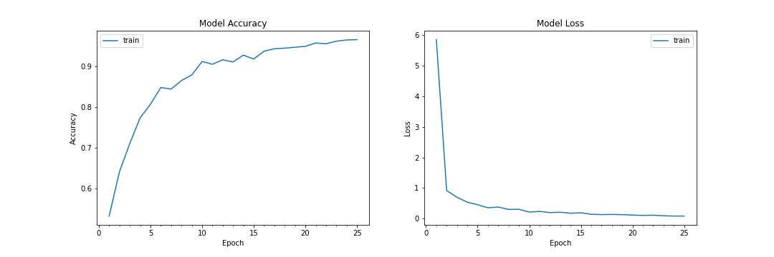

*Graph 3.3.A: Accuracy vs. Epoch*

The outputs of multiple epochs is shown in *figure3.3.1*. The loss and val_loss are decreasing and the acc and val_acc are increasing, this indicates that the model is trained in good way. The loss and acc data is of the training set and the val_loss and val_acc is on the validation data. After every epoch, loss improved is depicted in comparison with the last value recorded. After the successful run of 25 epochs, the training accuracy is 0.949140 or **94%** and the loss is 0.12. The test accuracy is 0.909561 or **90%** and loss for test data is 0.28.

(18)

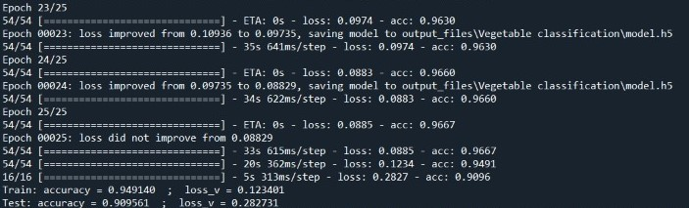

*Figure3.3.1: accuracy of model*

Convolutional Neural Network is made up of multiple layers of neurons. The layers mainly consists convolutional layers and pooling layers. Convolution layer contains a set of filters whose parameters need to be learned. A pooling layer is usually incorporated between two successive convolutional layers. The pooling layer reduces the number of parameters by down-sampling the representation. Max Pooling is commonly used as it works better. A report can be generated in Python console to have a tabular form data. It is shown in the *figure3.3.2* as the Model Summary. All the layers are represented here with the output shape and the number of parameters used in the model. The total number of parameters can be seen at the end of the table, 5,253,427.

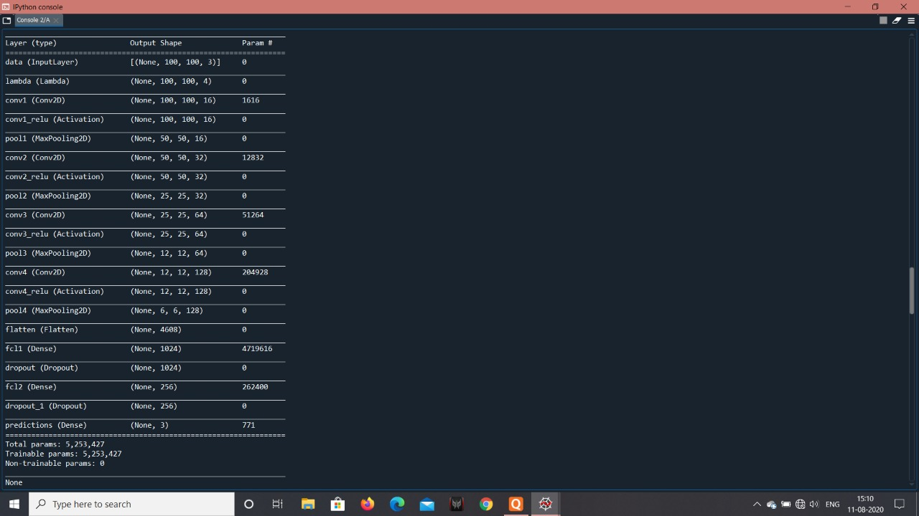

*Figure3.3.2: Model Summary*

(19)

Another report is called as a Classification report and it is used to measure the quality of predictions from a classification algorithm. The report has classified the model with metrics precision, recall ad f1-score on a per-class basis. Classification Report is shown in the *figure3.3.3.*

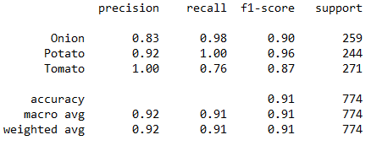

*figure3.3.3: Classification Report*

The ease of statistical classification for the machine learning model can be eliminated by the confusion matrix, also known as an error matrix. Confusion Matrix can be termed as a summary of prediction results on a classification problem and is shown in *figure3.3.4.*



*figure3.3.4: Confusion Matrix*

(20)

Another graph shows a ROC curve. An ROC curve (Receiver Operating Characteristics curve) is a graph showing the performance of a classification model at all classification thresholds. This curve plots two parameters: true Positive Rate and False Positive Ratio. AUC stands for Area under the ROC curve. It measures the entire two dimensional area underneath the entire ROC curve from (0,0) to (1,1). These ROC curve for classes Potato, Tomato and Onion is shown below in *graph 3.3.B, 3.3.C* and *3.3.D* respectively.

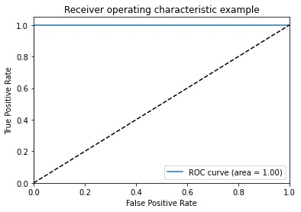

*Graph3.3.B: ROC curve for 1st Class*

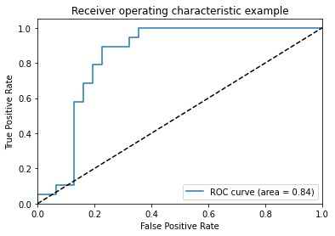

*Graph3.3.C: ROC curve for 2nd Class*

(21)

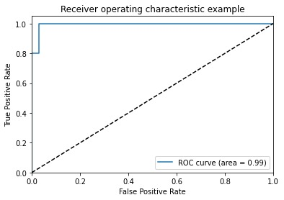

*Graph3.3.D: ROC curve for 3rd Class*

(22)

Table 1

Training and Testing Accuracy using different convolutional filter and Max pool size:

No. of Epochs- 25 Convolutional Tensor Max Pool Training Testing

Batch Size- 50 Filter Size Shape Size Accuracy Accuracy

16x3x3 32x32x3 2x2 0.7562 0.6572

Filter 1: 16x6x6 64x64x3 2x2 0.7758 0.6592

32x3x3 64x64x3 2x2 0.7762 0.6629

32x6x6 64x64x3 2x2 0.7812 0.6781

16x3x3 32x32x3 2x2 0.7566 0.7171

16x6x6 64x64x3 2x2 0.7778 0.7023

Filter 2: 32x6x6 64x64x3 2x2 0.7912 0.7321

64x3x3 64x64x3 2x2 0.8132 0.7421

16x5x5 100x100x3 2x2 0.8432 0.8145

32x5x5 100x100x3 2x2 0.8861 0.8263

Filter 3: 64x5x5 100x100x3 2x2 0.8892 0.8411

128x5x5 100x100x3 2x2 0.9241 0.8692

(23)

**Chapter 4: CONCLUSION**

This paper explores a vegetable classifier based on CNN algorithm. Significant challenges in terms of machine vision approach, feature selection & extraction and choice of appropriate hardware have been identified to overcome. Three classes were made to be distinguished in between and the total dataset was made for the training and testing purpose of machine learning model. The accuracy and loss curves are generated by using various combination of hidden layers with 25 epochs by using the private dataset. The hardware used for the image capturing is discussed and the main challenge was to choose the angle to shoot the images. We chose it to be 50°-70° from all the four directions. The system performance improve by considering the images from different directions. External properties of fruits like color, size, shape, texture and different defects are very important attributes of fruits for classification. The feature extraction recognizes the pattern and then during image processing, it starts from an initial set of measured data and builds derived values. All the codes were written in Python language to access the library like Keras, MatplotLib etc. This large dataset and the 25 epochs running for the dataset made this accuracy to be work at 95%. The GPU of the console is one of the most concerned part in the working of machine learning models. All the specifications of the hardware is been discussed in this paper for the better results. The algorithms is studied for the efficiency of the model and most pivotal ones are discussed. The MaxPooling helps decreasing the spatial distribution in the summarized dataset made by the Keras. The improved loss can be seen in the *figure3.3.1* and among all model achieved the best accuracy of 95% at epoch 25. The highest and lowest performance loss was found out with the presence of dropout. This low loss will provide CNN better performance to attain better recognition. We can also work on some more features here for grading and classification, which can identify types and/or texture structure of fruits. A generalized system may also be designed to grade or sort and detect the defects of multiple fruits and vegetables. These are future direction. We can work on these and prepare prototype model, which can be used in industries. A generalized system may also be designed to grade or sort and detect the defects of multiple fruits and vegetables.

(24)

**Chapter 5: REFERENCE/COMPARISON**

|  |  |  |  |  |  |  |
| --- | --- | --- | --- | --- | --- | --- |
| REFERENCES/  RESEARCH PAPERS  or  (DOI) | DATASET | NO. OF CLASSES  (TOTAL/  TRAINING/  TEST) | METHOD USED  (EPOCHS) | ACCURACY | PRECISION RECALL | LIMITATION |
| [7].    10.1007/978-3-030-37218-7_10 | Fruits-360 | 5 Class  (90483/  67692/  22688) | CNN,  2 Conv Layer,  20 epochs | 96.49% | 0.49 | Must be 3 conv. Layer, no ROC curve is shown. |
| [6].  10.13140/RG.2.2.31636.14723 | Fruits-360 | 5 Class  (17823/  14258/  3565) | CNN,  2 Conv Layer,  15 epochs | 99.79% | NA | Must be 3 conv. Layer, Less no. of Epochs. |
| [3].  10.1109/SSCI.2017.8285278 | Washington RGB-D object dataset | 4 Class  (6480/  5400/  1080) | CNN,  9 Conv Layer,  200 epochs | 92.9% | NA | Less no. images in dataset. |
| [4].  IDENTIFICATION AND CLASSIFICATION OF BULK FRUITS  IMAGES USING ARTIFICIAL NEURAL NETWORKS | Private Dataset | 5 Class  (6000/  5000/  1000) | ANN,  18 input node,  5 output node | 92.0% | NA | CNN architecture is best for image classification. |
| CLASSIFICATION OF AGRICULTURAL PERISHABLE FOOD ITEMS | Private Dataset | 4 Class  (3448/  2674/  774) | CNN,  4 Conv Layer,  25 epochs | 94.0% | 0.91 | Less no. images in dataset. |

(25)

[1]. Machine Vision based Fruit Classification and Grading – A Review, Sapan Naik and Bankim Patel, 2017.

[2]. Fruits and vegetables quality evaluation using computer vision: A review, Anuja Bhargava and Atul Bansal, 2018.

[3]. Grading Fruits and Vegetables using RGB-D images and Convolutional Neural Network, Toshiki Nishi, Shuichi Kurogi, Kazuyo Matsuo, 2017.

[4]. Identification and Classification of Bulk Fruits Images using Artificial Neural Networks, Dayanand Savakar, 2012.

[5]. A comprehensive review of fruit and vegetable classification techniques, Khurram Hamood, Douglas Chai, Alexander Rassau, 2018.

[6]. Implementation of Fruits Recognition Classifier using Convolutional Neural Network Algorithm for Observation of Accuracies for Various Hidden Layers, Shadman Sakib, Zahidun Ashrafi, Md. Abu Bakr Siddique, 2019.

[7]. Fruit Classification Using Traditional Machine Learning and Deep Learning Approach, N. Saranya, K. Srinivasan, S. K. Pravin Kumar, V. Rukkumani, R. Ramya, 2020.

[8]. https://towardsdatascience.com/feature-extraction-techniques-d619b56e31be

[9]. https://stackoverflow.com/questions/35819869/difference-between-parameters-features-and-class-in-machine-learning

[10]. https://machinelearningmastery.com/data-learning-and-modeling/

[11]. https://muthu.co/understanding-the-classification-report-in-sklearn/

(26)